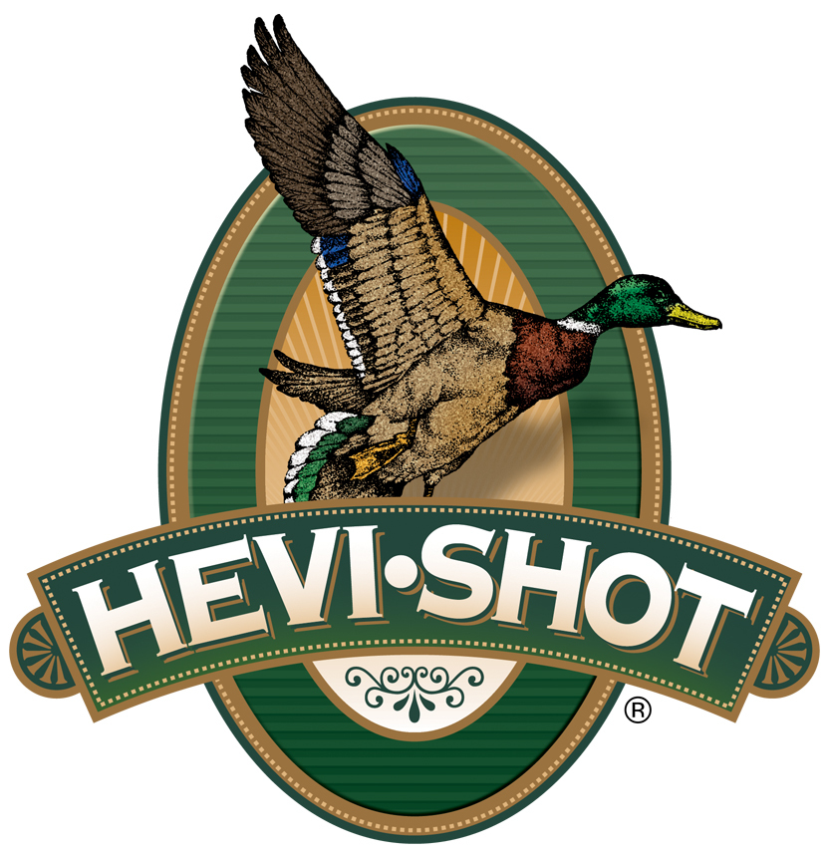

FOR IMMEDIATE RELEASE

HEVI-Shot Ammunition Releases A New HEVI-Bismuth Upland Game Load

SWEET HOME, Oregon – September 27, 2023 – HEVI-Shot is proud to release an expansion of its HEVI-Bismuth Upland product lineup. The new option is a 12-gauge, No. 3, 1 1/4-ounce, 2 3/4-inch load set at a muzzle velocity of 1,400 feet-per-second (fps). With this newly added load, HEVI-Shot’s HEVI-Bismuth Upland product line now consists of three total options: two 12-gauge and one 20-gauge.

HEVI-Bismuth Upland | Hevi Shot

“HEVI-Bismuth Upland is a good choice for bird hunters for several reasons. It features non-toxic bismuth pellets, so it’s safe to use in both classic and modern shotguns. It also has softer perceived recoil than traditional, heavier lead loads. And it produces amazing patterns,” said HEVI-Shot product manager Scott Turner. “Many people have a real need when it comes to finding a good load to use in their classic fixed-choke shotguns. And for that, HEVI-Bismuth is certainly the answer upland hunters are looking for.”

Other features include: 100-percent payload of 9.6 g/cc HEVI-Bismuth pellets are 22 percent denser than steel; Quality components with all-season reliability; Alloyed and loaded in Sweet Home, Oregon, U.S.A.; 25-round boxes; MSRP: $63.99.

For more information on all products from HEVI-Shot or to shop online, visit www.hevishot.com.

Press Release Contact: JJ Reich
Senior Manager – Press Relations
E-mail: VistaPressroom@VistaOutdoor.com

About HEVI-Shot
Established in 2000 and based out of Sweet Home, Oregon, HEVI-Shot is a brand of Vista Outdoor Inc., an outdoor sports and recreation company. HEVI-Shot is an industry leader in performance shotshell, providing the next generation of shotshell loads to hunters—with their large and impressive selection of hunting ammunition options. HEVI-Shot is synonymous with high performance projectiles. The company meticulously designs each product to outperform any ammunition competitor in its class. That is why HEVI-Shot is the ammunition choice for serious hunters who live by their slogan: “I DIDN’T COME THIS FAR TO MISS!”

