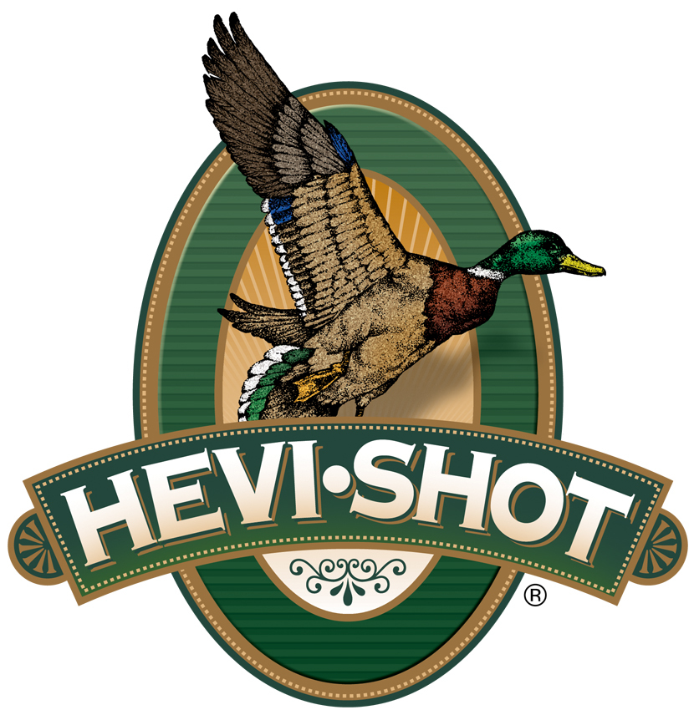

FOR IMMEDIATE RELEASE

HEVI-Shot Ammunition Releases A New HEVI-Hammer Waterfowl Load

SWEET HOME, Oregon – November 17, 2023 – HEVI-Shot is proud to release a new product line addition to its HEVI-Hammer Waterfowl load lineup. The new option is a 12-gauge, 1 1/2-ounce, 3 1/2-inch, shot size No. 2 load set at a muzzle velocity of 1,500 feet-per-second (fps). With this new load, HEVI-Shot’s HEVI-Hammer Waterfowl product line now consists of six total options: four 12-gauge and two 20-gauge.

HEVI-Hammer 12 Gauge (HS28302) | HEVI-Shot

HEVI-Hammer loads consist of layered bismuth pellets (15 percent of the payload) over steel pellets (85-percent). Stacked bismuth (15-percent) over steel (85-percent) payloads deliver more clean kills at longer ranges compared to straight steel payloads HEVI-Bismuth pellets deliver 38-percent more lethal yardage over steel with No. 2 and 3 shot and 41-percent more with No. 4. These design elements give hunters more range with added density, tighter patterns, and improved shot strings.

“Go big or go home,” said HEVI-Shot product manager Scott Turner. “We took our top-selling 3-inch loads in our HEVI-Hammer Waterfowl line and stretched them out to have heavier payloads and blistering velocities. The new 3-1/2-inch load is absolutely devastating on snow geese and other high-flying waterfowl targets.”

HEVI-Hammer is alloyed and loaded in Sweet Home, Oregon, U.S.A. It features all-season reliability, improved cold-weather performance, quality components, hotter primer, and clean-burning propellant. It is available in 25-round boxes; MSRP: $43.99.

For more information on all products from HEVI-Shot, visit www.hevishot.com.

Press Release Contact: JJ Reich
Senior Manager – Press Relations
E-mail: VistaPressroom@VistaOutdoor.com

About HEVI-Shot
Established in 2000 and based out of Sweet Home, Oregon, HEVI-Shot is a brand of Vista Outdoor Inc., an outdoor sports and recreation company. HEVI-Shot is an industry leader in performance shotshell, providing the next generation of shotshell loads to hunters—with their large and impressive selection of hunting ammunition options. HEVI-Shot is synonymous with high performance projectiles. The company meticulously designs each product to outperform any ammunition competitor in its class. That is why HEVI-Shot is the ammunition choice for serious hunters who live by their slogan: “I DIDN’T COME THIS FAR TO MISS!”

