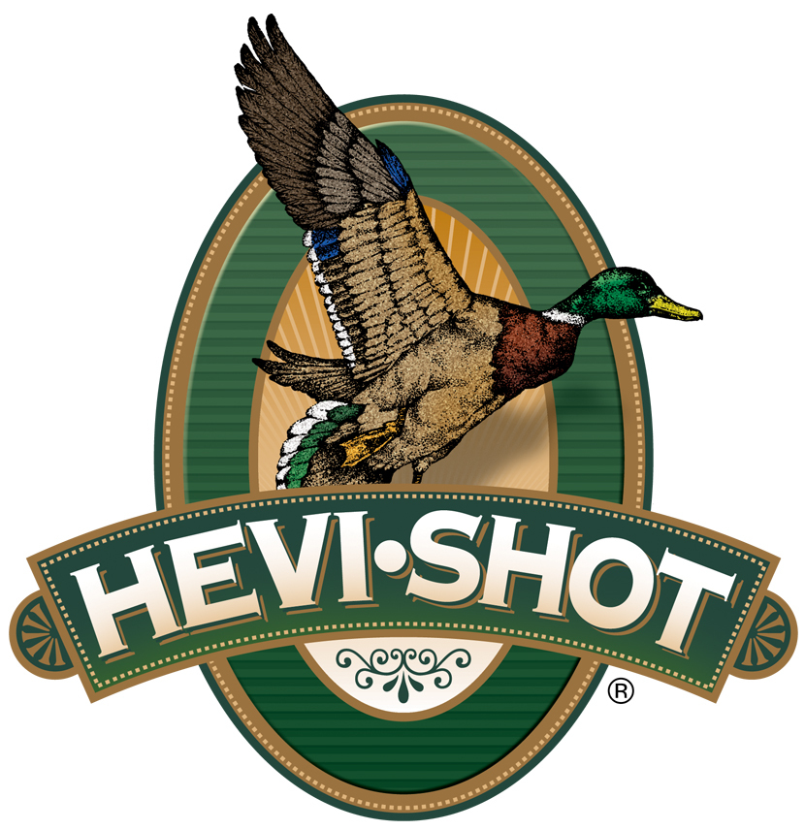

FOR IMMEDIATE RELEASE

HEVI-Shot Ammunition Adds All-New HEVI-Metal Xtreme In Size 2/BB

SWEET HOME, Oregon – October 17, 2023 – HEVI-Shot announces an expansion of its all-new HEVI-Metal Xtreme. The new option is a 12-gauge, Shot Size 2 and BB, 1 1/4-ounce, 3-inch load set at a muzzle velocity of 1,450 feet-per-second (fps). With this newly added load, HEVI-Shot’s HEVI-Metal Xtreme product line now consists of five total options: three 12-gauge and two 20-gauge.

HEVI-Metal Xtreme 12 Gauge HS38188 | HEVI-Shot

“HEVI-Metal Xtreme in Shot Size 2 and BB targets geese and other larger sized waterfowl,” said HEVI-Shot Product Manager Scott Turner. “This load features our original HEVI-Shot 12g/cc density tungsten shot stacked on top of precision steel pellets. That leading layer of 12 g/cc density tungsten hits 53-percent harder than the steel layer. This combination of shot materials and shot sizes certainly makes for an extremely powerful load, and I am sure diehard hunters will agree.”

HEVI-Shot’s all-new HEVI-Metal Xtreme loads feature a layer of HEVI-Shot’s original 12 g/cc HEVI-XII tungsten pellets (30 percent) stacked over steel pellets (70 percent) in the same shell. The new loads also feature the FLITECONTROL FLEX wad for consistent long-range patterns and is set to a high muzzle velocity.

Two product design elements really make this new product stand out: The dense, 12 g/cc tungsten pellets are three shot sizes smaller than the steel pellets to ensure the two layers of different shot types have similar downrange performance. The FLIGHTCONTROL FLEX wad is a rear-braking wad designed to improve pattern density and consistency. It can be used with any steel-rated choke—ported or non-ported alike.

HEVI-Metal Xtreme is alloyed and loaded in Sweet Home, Oregon, U.S.A. It features all-season reliability, quality components, hotter primer, and clean-burning propellant. It is available in 25-round boxes; MSRP: $59.99.

For more information on all products from HEVI-Shot, visit www.hevishot.com.

Press Release Contact: JJ Reich
Senior Manager – Press Relations
E-mail: VistaPressroom@VistaOutdoor.com

About HEVI-Shot
Established in 2000 and based out of Sweet Home, Oregon, HEVI-Shot is a brand of Vista Outdoor Inc., an outdoor sports and recreation company. HEVI-Shot is an industry leader in performance shotshell, providing the next generation of shotshell loads to hunters—with their large and impressive selection of hunting ammunition options. HEVI-Shot is synonymous with high performance projectiles. The company meticulously designs each product to outperform any ammunition competitor in its class. That is why HEVI-Shot is the ammunition choice for serious hunters who live by their slogan: “I DIDN’T COME THIS FAR TO MISS!”

