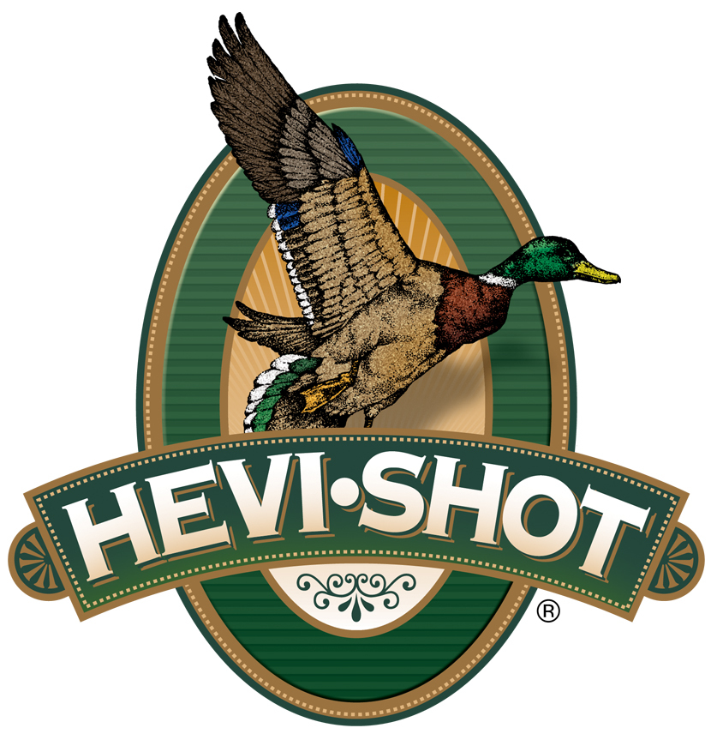

FOR IMMEDIATE RELEASE

HEVI-Shot Ammunition Releases New 410 Bore HEVI-XII Waterfowl Loads

SWEET HOME, Oregon – November 1, 2023 – HEVI-Shot is proud to release two new product line additions to its HEVI-XII Waterfowl lineup. The new load options are 410 bore, 1/2-ounce, 3-inch, in shot size No. 5 or 7, with a muzzle velocity of 1,250 feet-per-second (fps). HEVI-XII is the original 12-g/cc density, tungsten alloy recipe from HEVI-Shot. These new products are now shipping to dealers and are available.

HEVI-XII | Hevi Shot

“Everyone that has shot HEVI-XII has fallen in love with it, and now they can appreciate it in 410 shotguns,” said HEVI-Shot product manager Scott Turner. “HEVI-XII outperforms steel in every category. Smaller and more dense pellets penetrate deeper with more lethal pellets in a tighter pattern compared to shooting steel loads.”

HEVI-XII pellets hit harder from a longer distance. Its pellet material features a density of 12 grams per cubic centimeter (g/cc), meaning it is 53.8 percent denser than steel–doubling the downrange energy. Shooters can drop three shot sizes for the same lethality and 28 percent more devastating pellets on target.

HEVI-Shot’s HEVI-XII 410-bore waterfowl ammunition is alloyed and loaded in Sweet Home, Oregon in 25-round boxes with MSRP of $99.99.

For more information on all products from HEVI-Shot, visit www.hevishot.com.

Press Release Contact: JJ Reich
Senior Manager – Press Relations
E-mail: VistaPressroom@VistaOutdoor.com

About HEVI-Shot
Established in 2000 and based out of Sweet Home, Oregon, HEVI-Shot is a brand of Vista Outdoor Inc., an outdoor sports and recreation company. HEVI-Shot is an industry leader in performance shotshell, providing the next generation of shotshell loads to hunters—with their large and impressive selection of hunting ammunition options. HEVI-Shot is synonymous with high performance projectiles. The company meticulously designs each product to outperform any ammunition competitor in its class. That is why HEVI-Shot is the ammunition choice for serious hunters who live by their slogan: “I DIDN’T COME THIS FAR TO MISS!”

