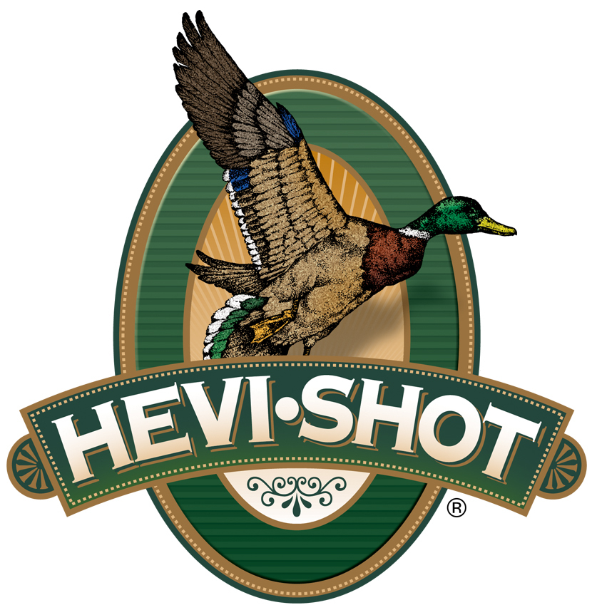

FOR IMMEDIATE RELEASE

HEVI-Shot Ammunition Releases New HEVI-XII Waterfowl Loads

SWEET HOME, Oregon – September 6, 2023 – HEVI-Shot is proud to release new product line additions to its HEVI-XII Waterfowl load lineup. HEVI-XII is the original 12-g/cc density, tungsten alloy recipe from HEVI-Shot. This full product line is available in an extensive list of including several new heavier payload options in shot size No. 2, 4 or 6, in 12- or 20 gauge. This new product is now shipping to dealers and is available.

HEVI-XII | Hevi Shot

“Everyone that has shot HEVI-XII has fallen in love with it,” said HEVI-Shot product manager Scott Turner. “The only feedback we received was that some hunters wanted heavier payloads for late season birds, so we delivered on that request with several new options for 2023.”

HEVI-XII pellets hit harder from a longer distance. Its pellet material features a density of 12 grams per cubic centimeter (g/cc), meaning it is 53.8 percent denser than steel–doubling the downrange energy. Shooters can drop three shot sizes for the same lethality and 28 percent more devastating pellets on target.

“HEVI-XII outperforms steel in every category. Smaller and more dense pellets penetrate deeper with more lethal pellets in a tighter pattern compared to shooting steel loads,” continued Turner. “If you pack HEVI-XII in, you’ll walk out carrying extra weight from harvested game. HEVI-XII delivers more kills, fewer cripples, and better stories. Plus, we proudly make the metal alloy and pellets, and load the shotshells the U.S.A.”

HEVI-Shot’s HEVI-XII waterfowl ammunition is alloyed and loaded in Sweet Home, Oregon in 25-round boxes with MSRP of $74.99 to $94.99, depending on product/gauge.

For more information on all products from HEVI-Shot, visit www.hevishot.com.

Press Release Contact: JJ Reich
Senior Manager – Press Relations
E-mail: VistaPressroom@VistaOutdoor.com

About HEVI-Shot
Established in 2000 and based out of Sweet Home, Oregon, HEVI-Shot is a brand of Vista Outdoor Inc., an outdoor sports and recreation company. HEVI-Shot is an industry leader in performance shotshell, providing the next generation of shotshell loads to hunters—with their large and impressive selection of hunting ammunition options. HEVI-Shot is synonymous with high performance projectiles. The company meticulously designs each product to outperform any ammunition competitor in its class. That is why HEVI-Shot is the ammunition choice for serious hunters who live by their slogan: “I DIDN’T COME THIS FAR TO MISS!”

