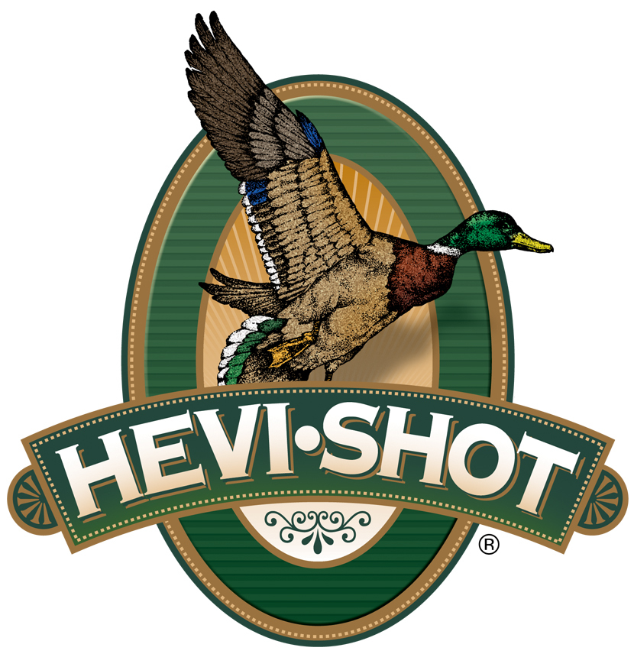

FOR IMMEDIATE RELEASE

HEVI-Shot HEVI-XII 3-inch 28-gauge Chosen as Best of the Best by Field & Stream

SWEET HOME, Oregon – December 15, 2023 – HEVI-Shot Ammunition is proud to be recognized for releasing the most impressive and innovative shotgun hunting ammo of the year by Field & Stream. Its annual Best of the Best gear roundup is one of the publication’s most popular features of the year. The editors, writers, and gear junkies of Field & Stream submitted nominations for new must-have hunting, fishing, and outdoor gear released in the past 12 months. This year, HEVI-Shot HEVI-XII 3-inch 28-gauge was chosen as Best of the Best in shotshell loads.

HEVI-XII | Hevi Shot

“While I am not yet sure what to make of the 28-gauge waterfowl trend, I can say this: You are not under-gunned with the HEVI-XII 3-inch 28-gauge. Naively, I thought I should give the little gun a chance, so I patterned it 35 yards instead of the usual 40,” said Field & Stream Editor Phil Bourjaily. “Any concerns I had about the small bore of the 28 patterning a magnum load well vanished when I started counting holes. At 35 yards with a factory Modified, the gun put 90 percent of the pellets inside a 30-inch circle. That totaled enough hits (over 110) that I would be comfortable shooting ducks and big geese with it at that range.”

HEVI-Shot’s HEVI-XII pellets hit harder from a longer distance. Its pellet material features a density of 12 grams per cubic centimeter (g/cc), meaning it is 53.8 percent denser than steel–doubling the downrange energy. Shooters can drop three shot sizes for the same lethality and 28 percent more devastating pellets on target. This waterfowl ammunition is alloyed and loaded in Sweet Home, Oregon in 25-round boxes with MSRP of $74.99 to $99.99, depending on product/gauge.

For more information on all products from HEVI-Shot, visit www.hevishot.com.

Press Release Contact: JJ Reich
Senior Manager – Press Relations
E-mail: VistaPressroom@VistaOutdoor.com

About HEVI-Shot
Established in 2000 and based out of Sweet Home, Oregon, HEVI-Shot is a brand of Vista Outdoor Inc., an outdoor sports and recreation company. HEVI-Shot is an industry leader in performance shotshell, providing the next generation of shotshell loads to hunters—with their large and impressive selection of hunting ammunition options. HEVI-Shot is synonymous with high performance projectiles. The company meticulously designs each product to outperform any ammunition competitor in its class. That is why HEVI-Shot is the ammunition choice for serious hunters who live by their slogan: “I DIDN’T COME THIS FAR TO MISS!”

