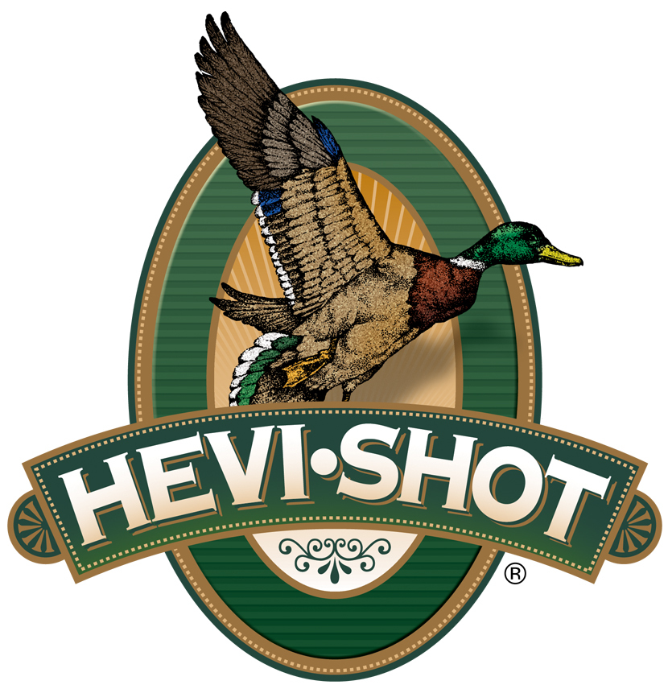

FOR IMMEDIATE RELEASE

HEVI-Shot Ammunition to Sponsor the 2023 Delta Waterfowl Expo

SWEET HOME, Oregon – July 25, 2023 – HEVI-Shot Ammunition will join the 2023 Delta Waterfowl Expo as an exhibitor and Teal Level Sponsor. The event will be held July 28-30, 2023 in downtown Little Rock, Arkansas. Visitors to the Expo can stop by booth No. 199 to see the latest and greatest products from HEVI-Shot.

“HEVI-Shot is proud to be one of the exhibitors and sponsors of the 2023 Delta Waterfowl Expo,” said Scott Turner, HEVI-Shot’s Product Manager. “We want to continue to help promote and support the mission of Delta Waterfowl and the great research and conservation work they are doing. We look forward to meeting with all the like-minded waterfowl enthusiasts at the Expo and celebrating Delta Waterfowl putting more ducks over decoys.”

Building on a legacy of conservation and management programs, the Delta Waterfowl Expo brings waterfowl hunters together. Over the three-day event, attendees can see the latest waterfowl gear, meet waterfowl hunters from all over the country, participate in raffles, and learn from experts at numerous seminars. The 2023 Delta Waterfowl Expo will continue to help Delta Waterfowl in their mission to create more waterfowl habitat back by proven conservation methods.

New for 2023, HEVI-Metal Xtreme features a 30% layer of original HEVI-Shot 12g/cc tungsten over 70% precision steel pellets. That leading layer of 12 density tungsten hits 53% harder than the steel layer! HEVI-Metal Xtreme also utilizes the FLIGHTCONTROL FLEX wad. This rear braking wad is designed to improve pattern density, consistency, and can be used with any steel rated choke (ported or non-ported alike).

For more information on all products from HEVI-Shot, visit www.hevishot.com.

Press Release Contact: JJ Reich
Senior Manager – Press Relations
E-mail: VistaPressroom@VistaOutdoor.com

About HEVI-Shot
Established in 2000 and based out of Sweet Home, Oregon, HEVI-Shot is a brand of Vista Outdoor Inc., an outdoor sports and recreation company. HEVI-Shot is an industry leader in performance shotshell, providing the next generation of shotshell loads to hunters—with their large and impressive selection of hunting ammunition options. HEVI-Shot is synonymous with high performance projectiles. The company meticulously designs each product to outperform any ammunition competitor in its class. That is why HEVI-Shot is the ammunition choice for serious hunters who live by their slogan: “I DIDN’T COME THIS FAR TO MISS!”

