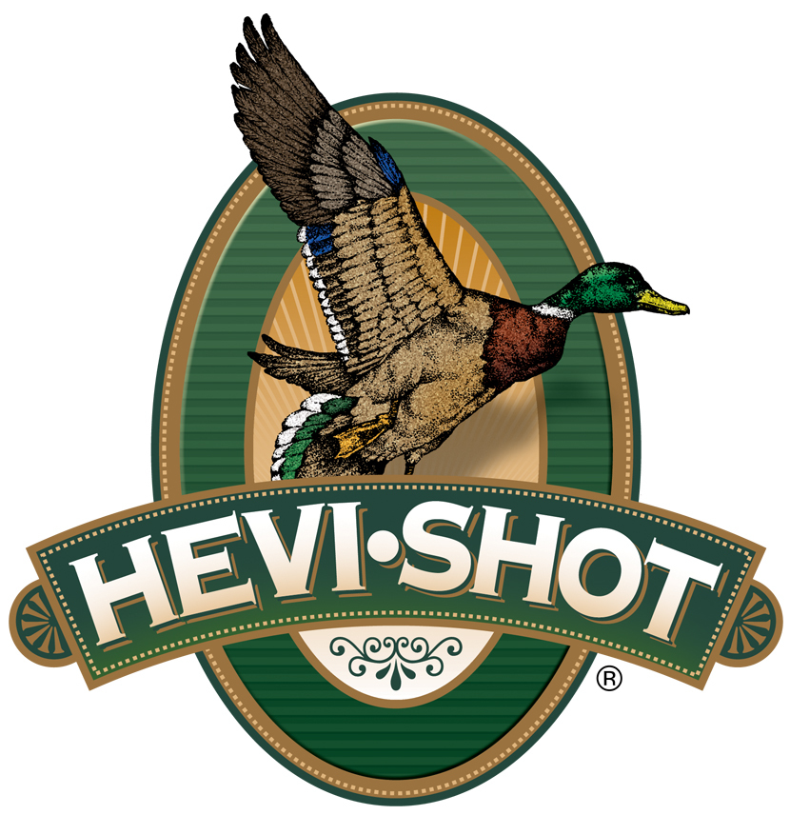

FOR IMMEDIATE RELEASE

New HEVI-Shot Merchandise Now Available for Holiday Shoppers

SWEET HOME, Oregon – December 5, 2023 – Requested by hunters across the country, HEVI-Shot Ammunition has added more choices of high-quality branded apparel for sale direct to consumers. Besides the new offerings, classic favorites such as popular short sleeve and long sleeve shirts have also been restocked.

“We get a lot of requests for new jackets, vests, hoodies, shirts, and hats from our loyal customers, and they are always excited when new designs come available,” said HEVI-Shot’s Marketing Manager Tina Larsen. “Our shotshells have made a lasting connection with HEVI-Shot fans who want to make our brand part of their everyday lifestyle. We are looking forward to hearing and seeing great comments and social posts from customers who buy our new gear this year.”

Product Highlights for December 2023 include:

HEVI-Shot / Drake Eqwader Camo Vest
The HEVI-Shot/Drake Eqwader Camo Vest combines the need for mid-layer, core insulation, freedom of movement in the arms, waterproof protection in the shoulders, and moisture-wicking, ultra-breathable 190-gram polyester fleece in the lower torso. With Magnattach left chest and vertical zippered right chest pockets, you can easily and securely store your cell phone for quick access as well as keep your duck calls warm and ready-to-go when the birds start working.

HEVI-Shot Cupped Duck Hoodie
The HEVI-Shot Hoodie is the perfect choice for a cozy day indoors or a breezy day outdoors. The 80/20 ring spun cotton/poly blend will keep you warm and comfortable all day long. The logo on the front and sleeve adds a touch of style, so you can show off your love for HEVI-Shot. The moss color is perfect for any season and will look great with any outfit. Whether you're out for a walk or lounging around the house, this hoodie is a must-have for any HEVI-Shot fan.

HEVI-Shot Duct Trucker Hat
The HEVI-Shot Duck Trucker Hat is the perfect accessory to go out in about. The mesh back ensures breathability while the logo patch adds a touch of style. The front is made from a blend of cotton and polyester, making it comfortable and durable. The snap back closure ensures a secure fit that won't slip off. Whether you're out hunting or taking a walk in the park, this hat is sure to keep you looking and feeling your best!

For more information on all products from HEVI-Shot, visit www.hevishot.com.

Press Release Contact: JJ Reich
Senior Manager – Press Relations
E-mail: VistaPressroom@VistaOutdoor.com

About HEVI-Shot
Established in 2000 and based out of Sweet Home, Oregon, HEVI-Shot is a brand of Vista Outdoor Inc., an outdoor sports and recreation company. HEVI-Shot is an industry leader in performance shotshell, providing the next generation of shotshell loads to hunters—with their large and impressive selection of hunting ammunition options. HEVI-Shot is synonymous with high performance projectiles. The company meticulously designs each product to outperform any ammunition competitor in its class. That is why HEVI-Shot is the ammunition choice for serious hunters who live by their slogan: “I DIDN’T COME THIS FAR TO MISS!”

