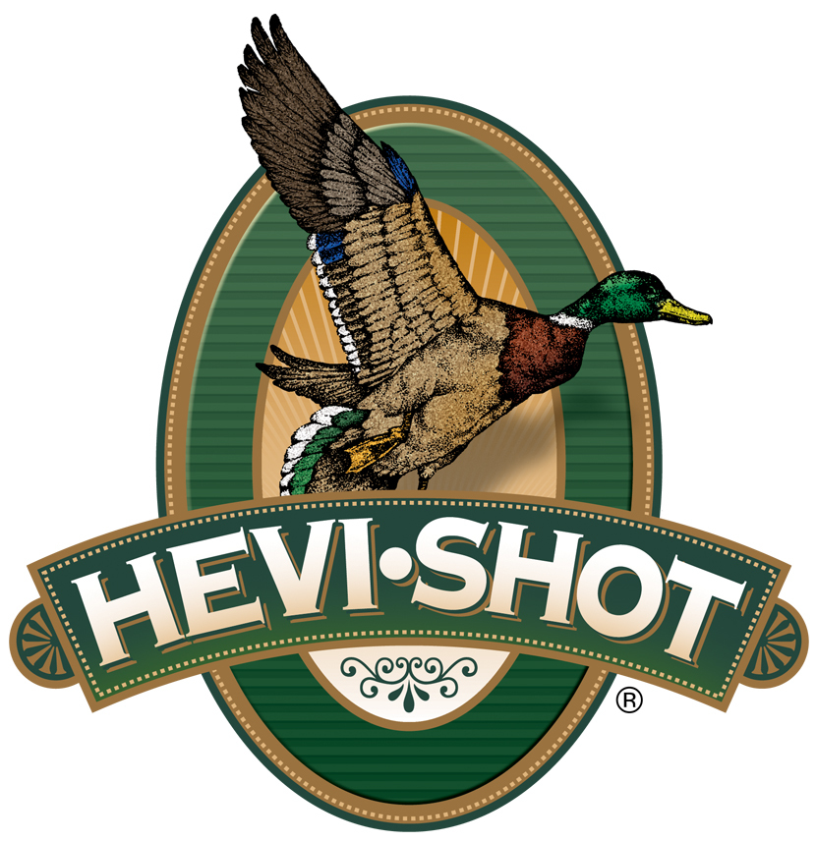

FOR IMMEDIATE RELEASE

HEVI-Shot Ammunition Announces New Upland Game and Turkey Loads for 2023

SWEET HOME, Oregon – January 9, 2023 – HEVI-Shot is proud to announce new upland game and wild turkey loads for 2023. Several new line extensions will be showcased and on display at the 2023 SHOT Show (Booth No. 11838), January 17–20 at the Venetian Expo and Caesars Forum in Las Vegas, Nevada. These additions include new offerings in HEVI-Shot’s HEVI-18, Magnum Blend, HEVI-Bismuth Upland, and HEVI-Hammer Upland & Dove product lines.

HEVI-18 TSS brings best-in-class performance to the turkey market with 18 g/cc density pellets in No. 7 and 9 shot. The loads provide high pellet counts, long-range lethality, and incredibly tight patterns thanks to the friction-free, sealed-in-the-shell spherical buffer. New loads are now available in reduced-recoil 12- and 20-gauge loads, as well as 28 gauge.

Like the original HEVI-Shot load, Magnum Blend offers three shot sizes (5, 6 and 7) in a single shell. The 12 g/cc cast tungsten lets you drop one shot size from lead for the same lethality. These heavy loads really pack some punch–437 deadly pellets in a single 12-gauge, 3-inch shell. New loads are now available in 3-inch 28 gauge.

Hunters can now hit upland birds harder with the power of 9.6 g/cc HEVI-Bismuth. These Upland loads are safe for classic and modern shotguns and available in a full line of options, including new offerings in 12, 16, 20 and 28 gauge, and .410 bore.

With 15 percent high-density bismuth layered over 85 percent steel pellets, HEVI Hammer packs nearly 50 percent more power than steel at 40 yards. Both bismuth and steel feature the same shot size for the energy that hits like a hammer. New 2-3/4-inch loads are now available in new shot size No. 3, 5 and 7 loads in 12 and 20 gauge.

Attendees of the 2023 SHOT Show are encouraged to stop by Booth No. 11838 for a first-hand look at these new products and more. Information about the new products and line extensions can soon be found on HEVI-Shot’s brand website.

For more information on all products from HEVI-Shot, visit www.hevishot.com.
Press Release Contact: JJ Reich
Senior Manager – Press Relations
E-mail: VistaPressroom@VistaOutdoor.com

About HEVI-Shot
Established in 2000 and based out of Sweet Home, Oregon, HEVI-Shot is a brand of Vista Outdoor Inc., an outdoor sports and recreation company. HEVI-Shot is an industry leader in performance shotshell, providing the next generation of shotshell loads to hunters—with their large and impressive selection of hunting ammunition options. HEVI-Shot is synonymous with high performance projectiles. The company meticulously designs each product to outperform any ammunition competitor in its class. That is why HEVI-Shot is the ammunition choice for serious hunters who live by their slogan: “I DIDN’T COME THIS FAR TO MISS!”

