FOR IMMEDIATE RELEASE

Remington’s 360 Buckhammer Now Shipping
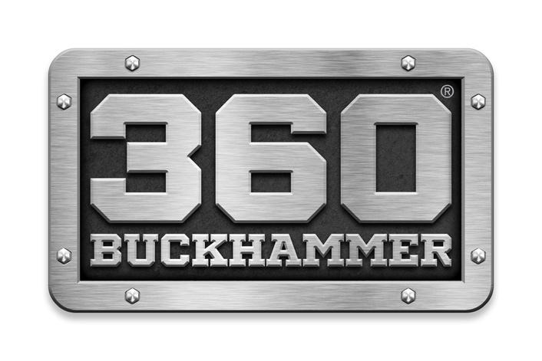

Lonoke, Arkansas – July 11, 2023 – Remington Ammunition has officially announced that the groundbreaking 360 Buckhammer cartridge is now shipping to dealers across the country. The Straight Up Better straight wall cartridge is optimized for lever-action rifles, deadly and accurate out to 200-yards or more, and is now available in both 180GR and 200GR Core-Lokt.

“Following our launch early this year, we’re thrilled to get 360 Buckhammer Core-Lokt into the hands of America’s hunters and shooters,” said Remington Ammunition’s Director of Centerfire Products Kris Carson. “Customer and consumer demand for this product is very high, and we’re working hard to deliver this innovative ammo right on time for deer season.”

New 360 Buckhammer is a game-changer for hunters nationwide. With lever action rifles available now from Henry Repeating Arms and handguns coming soon from Magnum Research, more 360 BHMR firearm options from other leading brands are soon to follow.

360 Buckhammer’s key features include:

- .358 diameter bullets
- 35% more energy than 350 Legend, higher velocity than 30-30 Win
- Accurate & deadly at 200 yards or more
- Available in trusted Core-Lokt: 180GR or 200GR
- Muzzle velocity: 2,215-2,400 FPS
- Ultimate straight wall cartridge
- MSRP = $36.99

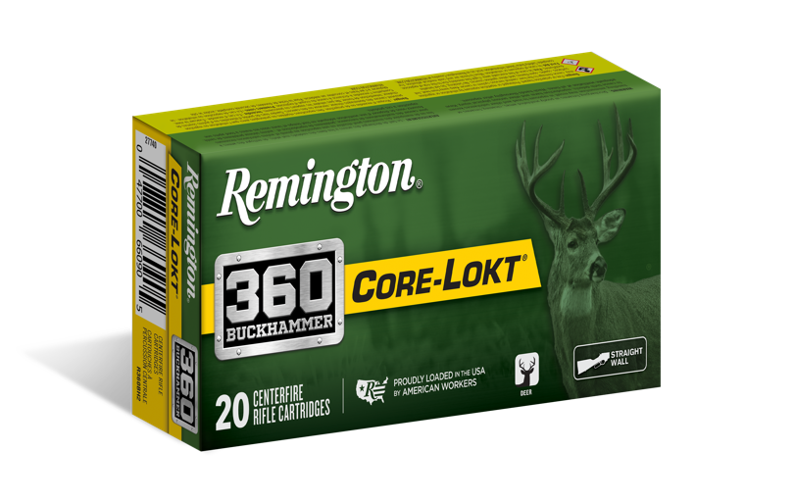

Learn more about 360 Buckhammer at www.remington.com/360buckhammer.

Find Remington ammunition at dealers nationwide and online. For more information on Remington ammunition and accessories, visit www.remington.com.

Press Release Contacts: Maggie Dazzio and Jonathan Harling
Remington Public Relations
E-mail: remingtonammopr@murrayroadagency.com

About Remington
From muskets to modern day, generations of hunters and shooters have trusted Remington ammunition and accessories. Loaded in Lonoke, Arkansas by American workers, our wide array of pioneering sporting and hunting ammunition promises to get the job done every time the trigger is pulled. At Remington, we’re here for everyone who loads a round of ammo into a handgun, rifle, or shotgun.

Founded in 1816, Remington and America have fought and won wars, put food on millions of tables and brought countless generations together at the range and in the field. We are proud of each and every round that rolls off our factory line. A brand of outdoor sports and recreation company Vista Outdoor, Remington is bringing a renewed focus to ammunition, innovation, and quality – all while staying true to Remington’s legendary heritage and stature as an American icon.

