FOR IMMEDIATE RELEASE

Remington Ammunition Introduces Groundbreaking 360 Buckhammer

Lonoke, Arkansas – January 16, 2023 – Remington Ammunition has announced the introduction of a revolutionary new cartridge, 360 Buckhammer. A Straight Up Better straight wall cartridge, 360 Buckhammer is optimized for lever-action rifles, deadly and accurate out to 200-yards or more.

The ultimate straight-wall cartridge, 360 Buckhammer will be available to hunters nationwide with lever action and single shot rifles available from launch partner Henry Repeating Arms. The new ammunition will be initially available in two new Core-Lokt loads, with more ammunition options to follow.

“360 Buckhammer is a game changer,” said Jason Vanderbrink, President of Remington Ammunition. “Whitetail hunters in much of the country needed a straight wall cartridge that functions flawlessly in a lever action rifle – and doesn’t compromise on accuracy or terminal performance. I’m proud to say the engineering teams at Remington and Henry have delivered.”
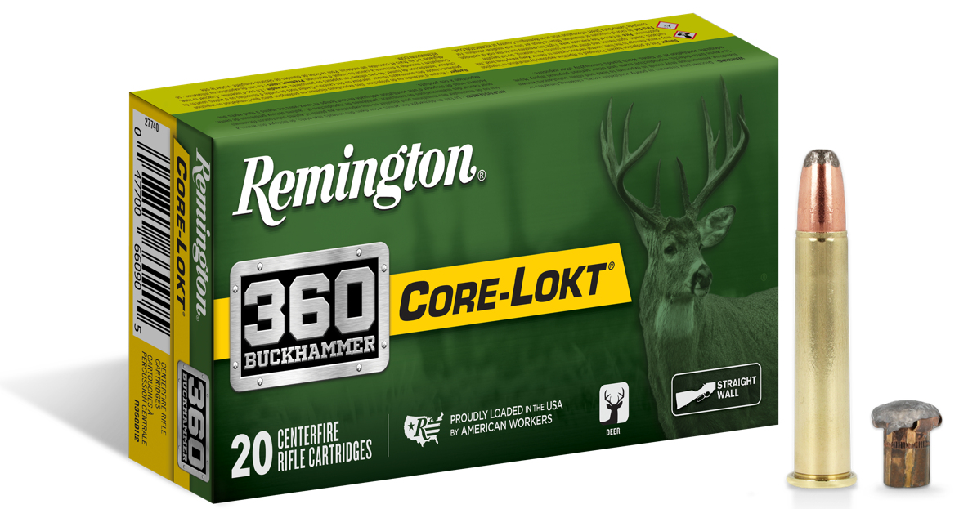

360 Buckhammer’s key features include:
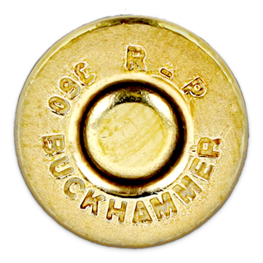
- Ultimate straight wall cartridge
- Accurate & deadly at 200 yards or more
- Easy to shoot with low recoil
- 35% more energy than 350 Legend
- Muzzle velocity: 2,215-2,400 FPS
- .358 diameter bullets deliver deadly results on-game
- Available in trusted Core-Lokt; 180GR or 200GR
- MSRP = $36.99
- Multiple lever-action rifle models, including a single-shot version, coming soon from Henry Rifles

Attendees of SHOT Show 2023 will receive a first-hand look at the 360 Buckhammer at Industry Day at the Range in the Henry Repeating Arms bay (SR-52). Learn more about this exciting new product at www.remington.com/360buckhammer.

Find Remington ammunition at dealers nationwide and online. For more information on Remington ammunition and accessories, visit www.remington.com.

Press Release Contact: Jonathan Harling
Remington Public Relations
E-mail: remingtonammopr@murrayroadagency.com

About Remington
From muskets to modern day, generations of hunters and shooters have trusted Remington ammunition and accessories. Loaded in Lonoke, Arkansas by American workers, our wide array of pioneering sporting and hunting ammunition promises to get the job done every time the trigger is pulled. At Remington, we’re here for everyone who loads a round of ammo into a handgun, rifle, or shotgun.

Founded in 1816, Remington and America have fought and won wars, put food on millions of tables and brought countless generations together at the range and in the field. We are proud of each and every round that rolls off our factory line. A brand of outdoor sports and recreation company Vista Outdoor, Remington is bringing a renewed focus to ammunition, innovation, and quality – all while staying true to Remington’s legendary heritage and stature as an American icon.

