FOR IMMEDIATE RELEASE

Remington's Premier Long Range Wins Best Centerfire Ammo by Field and Stream

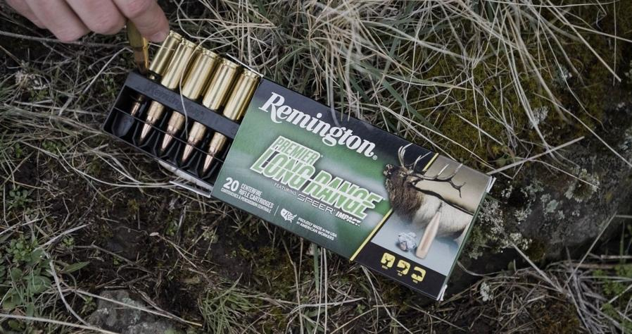

LONOKE, Ark. – December 13, 2023 – Remington Ammunition is proud to announce Remington's Premier Long Range ammunition has been awarded the Best Centerfire Ammo of 2023 by Field and Stream. This recognition is a testament to the exceptional quality and performance of Remington ammunition for big game hunting at extended ranges.

Field and Stream covers a wide range of topics including hunting and fishing tactics from the pros, gear reviews and thrilling adventure stories. Their endorsement of Remington's Premier Long Range further solidifies its position as the go-to ammunition for big game hunters.

Featuring Speer’s revolutionary Impact bullet, Remington's Premier Long Range boasts a tough and bonded construction that ensures high weight retention, resulting in deadly terminal performance on big game, regardless of the distance. The bullet's sleek construction, tightly tapered hybrid ogive, boat-tail, rear-adjusted center of gravity and SlipStream™ Tip offer high ballistic coefficients, a flat trajectory and extreme accuracy, making it the ultimate choice for long-range hunting.

"We are thrilled to receive this prestigious recognition from Field and Stream," said Kris Carson, Remington Ammunition’s centerfire rifle product line director. "Remington has always been committed to providing hunters with the highest quality ammunition, and this award is a testament to our dedication to excellence."

Find Remington ammunition at dealers nationwide and online. For more information on Remington ammunition and accessories, visit www.remington.com.

Press Release Contact: Maggie Dazzio and Jonathan Harling
Remington Public Relations
E-mail: remingtonammopr@murrayroadagency.com

About Remington
From muskets to modern day, generations of hunters and shooters have trusted Remington ammunition and accessories. Loaded in Lonoke, Arkansas by American workers, our wide array of pioneering sporting and hunting ammunition promises to get the job done every time the trigger is pulled. At Remington, we’re here for everyone who loads a round of ammo into a handgun, rifle, or shotgun.

Founded in 1816, Remington and America have fought and won wars, put food on millions of tables and brought countless generations together at the range and in the field. We are proud of every round that rolls off our factory line. A brand of outdoor sports and recreation company Vista Outdoor, Remington is bringing a renewed focus to ammunition, innovation, and quality – all while staying true to Remington’s legendary heritage and stature as an American icon.

