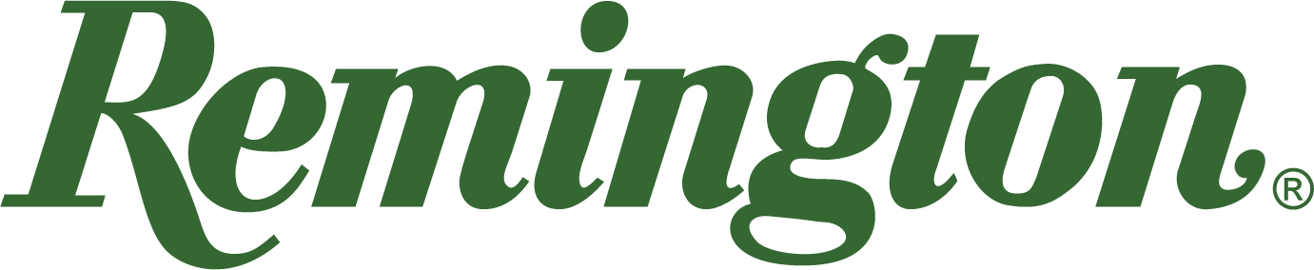

FOR IMMEDIATE RELEASE

Team Remington’s Madison Sharpe Wins Again: Seminole Cup Ladies Division HOA

Lonoke, Arkansas – March 10, 2023 – Remington Ammunition is proud to announce that Team Remington’s Madison Sharpe won 1st place in the Seminole Cup Main Event Ladies Division during the 30th Anniversary of the Seminole Cup Sporting Clays Championship in Woodbine, Ga., March 1-5, 2023.

In addition to her Ladies Division HOA finish in the Main Event, Sharpe also took home 1st place honors in the 5-stand ladies division and runner-up in the FITASC ladies event.

“Madison’s performance at these clay target tournaments is nothing short of amazing,” said Mike Hampton, Team Remington Manager. “She has been a great addition to the team and continues to make great strides in proving why Big Green offers the best of the best in ammunition performance. We are proud of Madison and all of Team Remington’s accomplishments and dominating performances, and we look forward to seeing what the rest of the 2023 competition shooting circuit has to offer.”

The Seminole Cup began 30 years ago as a promotion for Seminole Gunworks at a small shooting club in Florida. The event is now hosted at Broadfield Plantation, Sea Island’s 5,800-acre Sporting Club and Lodge. Broadfield opens its door once a year for this premier sporting clays event. The Seminole Cup is also known as the Sea Island Sporting Classic.

Team Remington is comprised of an accomplished list of top shooters who continue to compete with the best in the world across trap, skeet and sporting clays competitions domestically and internationally. Utilizing Remington Premier STS Target Loads, Team Remington shooters continue to tally podium finishes and represent Big Green against the best shooters in the world.

Find Remington ammunition at dealers nationwide and online. For more information on Remington ammunition and accessories, visit www.remington.com.

Press Release Contacts: Maggie Dazzio and Jonathan Harling
Remington Public Relations
E-mail: remingtonammopr@murrayroadagency.com

About Remington
From muskets to modern day, generations of hunters and shooters have trusted Remington ammunition and accessories. Loaded in Lonoke, Arkansas by American workers, our wide array of pioneering sporting and hunting ammunition promises to get the job done every time the trigger is pulled. At Remington, we’re here for everyone who loads a round of ammo into a handgun, rifle, or shotgun.

Founded in 1816, Remington and America have fought and won wars, put food on millions of tables and brought countless generations together at the range and in the field. We are proud of every round that rolls off our factory line. A brand of outdoor sports and recreation company Vista Outdoor, Remington is bringing a renewed focus to ammunition, innovation, and quality – all while staying true to Remington’s legendary heritage and stature as an American icon.

