FOR IMMEDIATE RELEASE

Deadly Duplex Dual Shot: Remington Announces Nitro-Steel Duplex

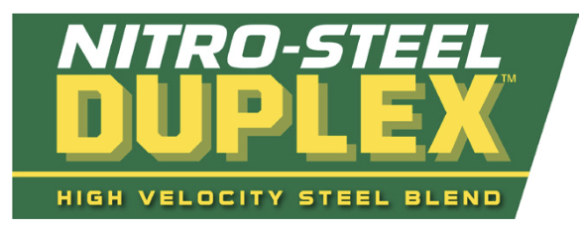

Lonoke, Arkansas – October 2, 2023 – Remington Ammunition is thrilled to announce the newest Nitro-Steel load, the Nitro-Steel Duplex. The essential steel loads trusted by dedicated waterfowl hunters have now achieved unparalleled performance levels.

“Designed with the needs of avid waterfowl hunters in mind, we’re thrilled to announce the new Nitro-Steel Duplex,” said Remington’s Product Line Manager Ronnie Evans. “Big Green is working around the clock to produce the best shotshell ammunition available. Loaded with top-tier Remington components, Nitro-Steel Duplex serves as the ultimate waterfowl load of the season.”

Remington Duplex shells are loaded with a combination of two different sizes of steel shot, optimizing performance across all distances. The blend of high-velocity magnum steel payload creates concentrated patterns up close with the smaller shot, while the larger shot delivers robust impact nearby and sustains energy for longer distances.

Nitro-Steel Duplex offers peak performance with a choice of four different shot combinations, featuring 2x4 and 2x6 shot sizes available now.

Features include:

- Duplex™ Shot Load: Two shot sizes for deadly patterns at all ranges
- Nitro Velocity: Maximum velocity for true magnum-blended steel payloads
- Power Piston™ Wad: Tough, versatile wad cushions shot and performs across wide range of choke tubes
- Ultra Capacity Stealth Hull: High base, quality head and drab hull for less reflection

Part No. / Description / MSRP

R20323 / 12 Gauge, BBx2 Shot Size / $39.99
R26643 / 12 Gauge, 2x6 Shot Size / $39.99
R26645 / 12 Gauge, BBx4 Shot Size / $39.99
R20321 / 12 Gauge, 2x4 Shot Size / $39.99

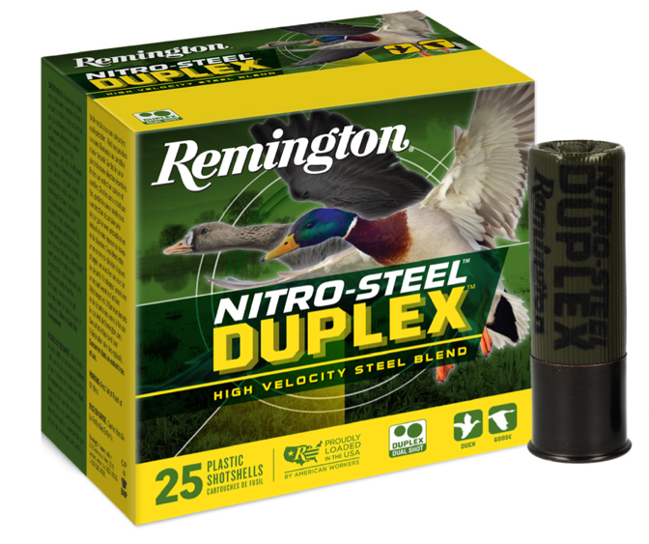

To learn more about Nitro-Steel Duplex, visit www.remington.com/nitro-steel-duplex.

Find Remington ammunition at dealers nationwide and online. For more information on Remington ammunition and accessories, visit www.remington.com.

Press Release Contact: Maggie Dazzio and Jonathan Harling
Remington Public Relations
E-mail: remingtonammopr@murrayroadagency.com

About Remington
From muskets to modern day, generations of hunters and shooters have trusted Remington ammunition and accessories. Loaded in Lonoke, Arkansas by American workers, our wide array of pioneering sporting and hunting ammunition promises to get the job done every time the trigger is pulled. At Remington, we’re here for everyone who loads a round of ammo into a handgun, rifle, or shotgun.

Founded in 1816, Remington and America have fought and won wars, put food on millions of tables and brought countless generations together at the range and in the field. We are proud of every round that rolls off our factory line. A brand of outdoor sports and recreation company Vista Outdoor, Remington is bringing a renewed focus to ammunition, innovation, and quality – all while staying true to Remington’s legendary heritage and stature as an American icon.

