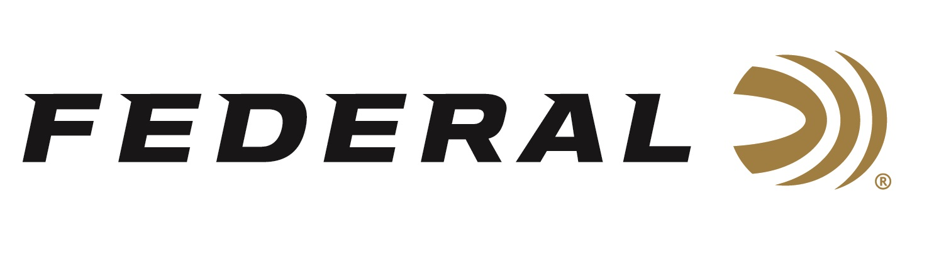
FOR IMMEDIATE RELEASE

Federal Ammunition Announces New Branded Accessories:
Bags, Pouches, and Cases

ANOKA, Minnesota – January 24, 2024 – Federal Ammunition announces the launch of its new line of range and field-ready accessories. New for 2024, the full collection of Federal branded accessories is designed to cater to the needs of shooters and hunters at every level. Three new product lines: Premium, Field & Range, and Top Gun will be offered to fulfill the needs of any shooter or hunter.

“Designed by hunters and shooters for the range, field and blind, Federal’s new accessories include a full line of gun cases, shell pouches and range bags," said Federal Accessories Product Line Manager Jake Jacobs. “Our new line of accessories are built for convenience, protection and accessibility, and there are several styles available in each product category to fulfill various needs and price points.”

Shoot in style with Premium bags and gear. The lineup includes shotgun and rifle cases as well as shell and range bags. All are built with the finest materials, including 18-ounce waxed canvas, top-quality zippers, leather accents, brass hardware, and embossed leather logo patches.

Count on the Federal Field & Range line for stylish, functional shotgun and rifle cases that provide flotation up to 12 pounds. Quality zippers, robust padding, and rugged, waterproof 600 denier polyester construction promise years of use.

Protect firearms during transport without having to deal with bulky gear once you arrive at your destination. The Federal Tri-Fold Gun Case folds down for easy storage and is built with rugged, long-lasting material that keeps firearms safe.

Federal's Top Gun line includes a variety of shotgun cases, scoped rifle cases, shell bags and range bags—all with durable construction and an embroidered logo. This line is for hunters and shooters looking for solid, dependable gear at an affordable price.

Give firearms next-level protection with the Federal Neoprene Gun Sleeve. Its 53-inch length fits most long guns, and the rugged ripstop stretch neoprene keeps them safe in any condition.

Federal ammunition can be found at dealers nationwide. For more information on all products from Federal, visit www.federalpremium.com.
Press Release Contact: JJ Reich
Senior Manager – Press Relations
E-mail: VistaPressroom@VistaOutdoor.com

About Federal Ammunition
Federal, headquartered in Anoka, MN, is a brand of Vista Outdoor Inc., an outdoor sports and recreation company. From humble beginnings nestled among the lakes and woods of Minnesota, Federal Ammunition has evolved into one of the world's largest producers of sporting ammunition. Beginning in 1922, founding president, Charles L. Horn, paved the way for our success. Today, Federal carries on Horn's vision for quality products and service with the next generation of outdoorsmen and women. We maintain our position as experts in the science of ammunition production. Every day we manufacture products to enhance our customers' shooting experience while partnering with the conservation organizations that protect and support our outdoor heritage. We offer thousands of options in our Federal Premium and Federal® lines-it's what makes us the most complete ammunition company in the business and provides our customers with a choice no matter their pursuit.

