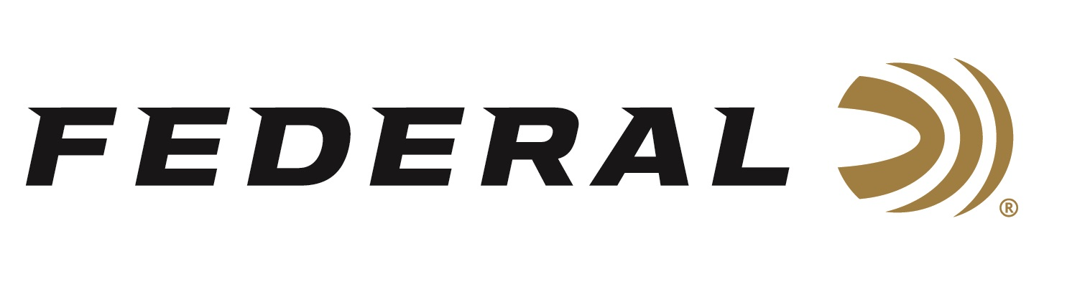
FOR IMMEDIATE RELEASE

Federal Ammunition’s New Champion Training 30 Super Carry Now Available

ANOKA, Minnesota – July 1, 2024 – Federal Ammunition adds a 30 Super Carry, 90 Grain Full Metal Jacket load to its popular Champion Training handgun product line. This new load is now available at select dealers.

“Great performance at a competitive price point makes the new Federal Champion Training 30 Super Carry FMJ load an excellent practice round,” said Chris Laack, Federal’s Handgun Ammunition Product Manager. “This new, lighter-weight, 90-grain load provides low felt recoil for longer, more comfortable training sessions.”

The new 30 Super Carry cartridge offers a significant terminal performance boost over the 380 Auto with as much muzzle energy as a 9mm Luger. Its compact size delivers increased carrying capacity with excellent power and performance. With it, shooters can hold 12-13 rounds in a magazine similar to the size of a 10-round 9mm Luger.

“Our American Eagle 30 Super Carry 100-grain training load is already a light recoiling, easy-to-shoot load, even though it’s matched to our Personal Defense HST 100-grain load to deliver the same feel and point of impact,” continued Laack. “However, this new lighter-weight Champion Training 30 Super Carry 90-grain load feels even easier, softer, less recoiling, and more fun to shoot.”

Federal’s Champion handgun loads provide accurate, target-grade performance. They’re loaded with quality, reliable brass and primers. They deliver consistent performance, are ideal for target practice, and are priced for volume shooters.

The current Champion handgun product lineup includes ten cartridge options. The new 30 Super Carry 90 Grain FMJ loads are available in 50-round boxes with an MSRP of $31.99.

Learn more about Champion Training.

Federal ammunition can be found at dealers nationwide. For more information on all products from Federal or to shop online, visit www.federalpremium.com.

Press Release Contact: JJ Reich
Senior Manager – Press Relations
E-mail: Ammunition@tkghunt.com

About Federal Ammunition
Federal, headquartered in Anoka, MN, is an ammunition brand of The Kinetic Group. From humble beginnings nestled among the lakes and woods of Minnesota, Federal Ammunition has evolved into one of the world's largest producers of sporting ammunition. Beginning in 1922, founding President Charles L. Horn paved the way for our success. Today, Federal carries on Horn's vision for quality products and services with the next generation of outdoorsmen and women. We maintain our position as experts in the science of ammunition production. Every day, we manufacture products to enhance our customers' shooting experience while partnering with the conservation organizations that protect and support our outdoor heritage. We offer thousands of options in our Federal Premium and Federal® lines, which makes us the most complete ammunition company in the business and provides our customers with a choice no matter their pursuit.

