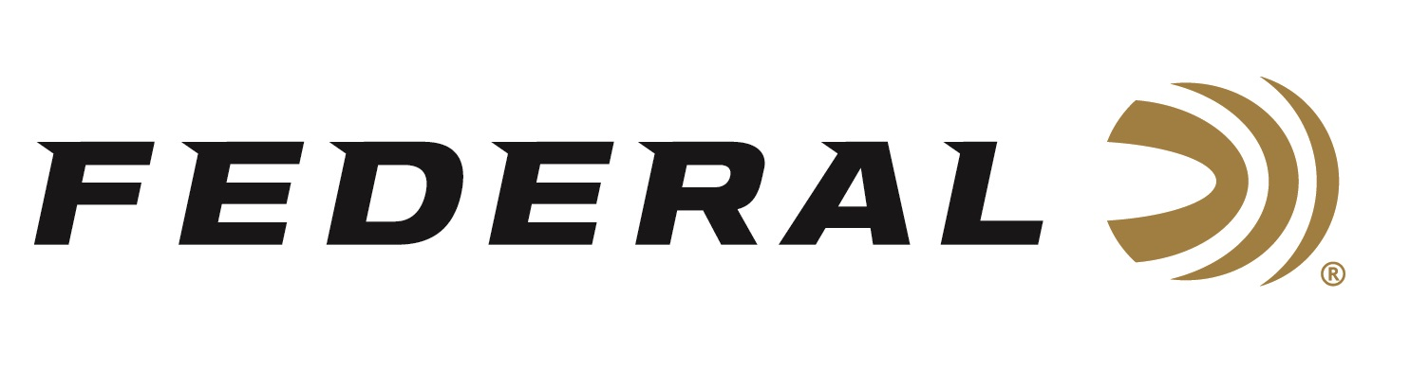

FOR IMMEDIATE RELEASE

Federal Ammunition’s Austen Smith Secures Her Spot on the
USA Shooting Women’s Skeet Team

ANOKA, Minnesota – March 22, 2024 – Federal Ammunition congratulates sponsored shooter Austen Smith for securing her spot on the 2024 USA Shooting Women’s Skeet team, headed to the summer games in Paris. Smith had a phenomenal performance during the Shotgun Selection Match, March 11-17 at the Tucson Trap and Skeet Club in Tucson, Arizona.

This will be Smith’s second appearance at the summer games. She was the youngest member of the 2021 USA Shooting team in Tokyo, where she finished 10th place. She had only been shooting for 7 years prior to making it to her first games. Smith is coached by three-time Olympic Champion Vincent Hancock.

“We congratulate Austen Smith, and all our sponsored shooters for their exceptional performances all year long to make it on the team headed to Paris. These athletes compete at the highest level. They are extremely accomplished and work hard to compete for their country on the world’s greatest stage,” said Jason Nash, Federal’s Vice President of Marketing. “We can’t wait to watch them compete and represent our great country.”

Smith’s most recent competition achievements include: Gold and a new world record in Mixed Skeet Team at the 2023 ISSF World Championship; Gold in Women's Skeet Team at the 2022 World Championship; Gold in 3-Woman Skeet Team and Silver in Mixed Skeet Team at the 2022 World Cup Lima; Gold in Women’s Skeet at the 2021 ISSF World Cup Lonato; and many more.

Shotgunners on Team Federal use Federal Premium Gold Medal and Top Gun shells, all designed to shoot smoothly and produce dense, uniform shot patterns that turn clay pigeons to dust. Federal is the number one choice for shotgun shells and manufactures products in America for all competitive and recreational disciplines. See the full lineup, including the latest High Over All, at www.federalpremium.com.

To support America’s shooting team, visit www.usashooting.org to find out more.

Photo courtesy Josh Schave/USA Shooting.
Press Release Contact: JJ Reich
Senior Manager – Press Relations
E-mail: Ammunition@tkghunt.com

About Federal Ammunition
Federal, headquartered in Anoka, MN, is an ammunition brand of The Kinetic Group. From humble beginnings nestled among the lakes and woods of Minnesota, Federal Ammunition has evolved into one of the world's largest producers of sporting ammunition. Beginning in 1922, founding president, Charles L. Horn, paved the way for our success. Today, Federal carries on Horn's vision for quality products and service with the next generation of outdoorsmen and women. We maintain our position as experts in the science of ammunition production. Every day we manufacture products to enhance our customers' shooting experience while partnering with the conservation organizations that protect and support our outdoor heritage. We offer thousands of options in our Federal Premium and Federal® lines-it's what makes us the most complete ammunition company in the business and provides our customers with a choice no matter their pursuit.

