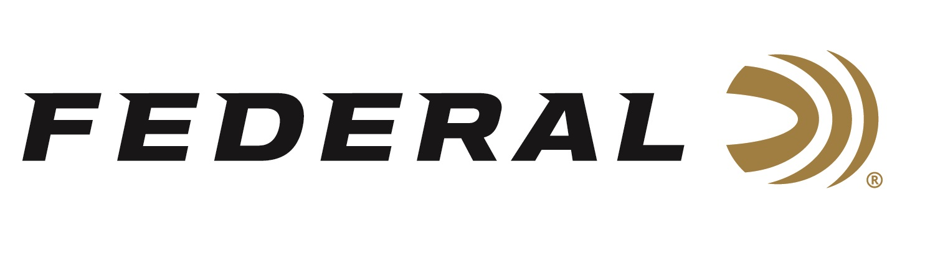

FOR IMMEDIATE RELEASE

Team Federal Captures Gold in Mixed Team Skeet at ISSF World Cup

ANOKA, Minnesota – June 19, 2024 – Team Federal continued its astonishing performance this year by capturing gold and bronze medals at the ISSF World Cup in Lonato, Italy, held June 10-19, 2024. Team Federal’s Vincent Hancock, three-time Olympic champion, and Austen Smith won gold in Mixed Team Skeet for the United States, just as they did at the same venue last year. Smith also captured a bronze medal in Women’s Skeet.

“Both Vincent and Austen perform with a high level of professionalism repeatedly. They love shooting together and are certainly fun to watch,” said Jason Nash, Federal Vice President of Marketing. “We know that talents of their level have to trust the best equipment available, and we are proud to have both of them as part of Team Federal.”

As reigning world champions, Hancock and Smith will carry high ambitions into Paris 2024, as they will be partnered up in Mixed Team Skeet. Interviewed by USA Shooting, Smith had this to say about it: “It’s a brand new event for the Olympics, and we feel we are made for this event as the United States men’s and women’s skeet teams are extremely strong. We feel ready to make history!”

The 2024 Summer Games will be Smith’s second appearance on the world’s largest stage. She was the youngest member of the 2020 USA Shooting team, finishing 10th place. Hancock will seek a fourth individual title in Paris this summer after winning gold at the Beijing 2008, London 2012, and Tokyo 2020 Games.

“If you would have asked me when I started this sport, if I would be competing in five Olympic games and have the potential for four individual gold medals, I would have probably laughed!” said Hancock. “It's an extremely difficult sport, made even harder by an ever-rising level of competition. Looking back on it now, I'm thankful for every opportunity God has given me to do my best and have the chance to go for gold.”

Shotgunners on Team Federal use Federal Premium Gold Medal and High Over All shells, designed to shoot smoothly and produce dense, uniform shot patterns that turn clay pigeons to dust.

Federal is the number one choice for shotgun shells and manufactures products in America for all competitive and recreational disciplines. See the full lineup, including the latest High Over All, at www.federalpremium.com.
To support America’s shooting team, visit www.usashooting.org to find out more.

Federal ammunition can be found at dealers nationwide. For more information on all products from Federal or to shop online, visit www.federalpremium.com.

Press Release Contact: JJ Reich
Senior Manager – Press Relations
E-mail: Ammunition@tkghunt.com

About Federal Ammunition
Federal, headquartered in Anoka, MN, is an ammunition brand of The Kinetic Group. From humble beginnings nestled among the lakes and woods of Minnesota, Federal Ammunition has evolved into one of the world's largest producers of sporting ammunition. Beginning in 1922, founding president, Charles L. Horn, paved the way for our success. Today, Federal carries on Horn's vision for quality products and service with the next generation of outdoorsmen and women. We maintain our position as experts in the science of ammunition production. Every day we manufacture products to enhance our customers' shooting experience while partnering with the conservation organizations that protect and support our outdoor heritage. We offer thousands of options in our Federal Premium and Federal® lines-it's what makes us the most complete ammunition company in the business and provides our customers with a choice no matter their pursuit.

