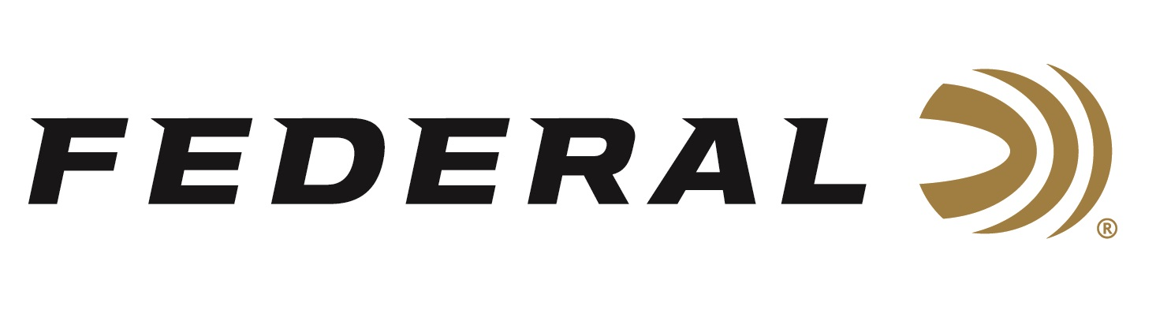

FOR IMMEDIATE RELEASE

**Federal Ammunition Sponsored Shooter Austen Smith Wins Gold**

**at the ISSF World Cup in Baku**

**ANOKA, Minnesota – May 13, 2024 –** Federal Ammunition congratulates sponsored shooter Austen Smith for winning Gold at the ISSF World Cup, May 1-12, 2024, in Baku, Azerbaijan, in Women’s Skeet. Additionally, Smith and her teammate Conner Prince advanced to the Bronze medal match in Mixed Team Skeet, however they lost to a team from Australia by one target.

Earlier this year, Smith secured a spot on the 2024 USA Shooting Women’s Skeet team, headed to the summer games in Paris, during the Shotgun Selection Match at the Tucson Trap and Skeet Club in Tucson, Arizona held this past March. This will be Smith’s second appearance at the summer games. She was the youngest member of the 2021 USA Shooting team in Tokyo where she finished 10th place.

“We congratulate Austen Smith for winning gold at this prestigious match. And we congratulate all our sponsored shooters for their exceptional performances year-round,” said Jason Nash, Federal’s Vice President of Marketing. “They are extremely accomplished and work hard to compete for our country on the world’s greatest stage. We can’t wait to watch them compete and represent our great country in Paris this summer.”

Federal is the number one choice for shotgun shells and manufactures products in America for all competitive and recreational disciplines. See the full lineup, including the latest High Over All, at [www.federalpremium.com](http://www.federalpremium.com).

Federal ammunition can be found at dealers nationwide. For more information on all products from Federal or to shop online, visit [www.federalpremium.com](http://www.federalpremium.com).

To support America’s shooting team, visit [www.usashooting.org](http://www.usashooting.org) to find out more.

**Press Release Contact: JJ Reich**

Senior Manager – Press Relations

E-mail: [Ammunition@tkghunt.com](mailto:Ammunition@tkghunt.com)

**About Federal Ammunition**

Federal, headquartered in Anoka, MN, is an ammunition brand of The Kinetic Group. From humble beginnings nestled among the lakes and woods of Minnesota, Federal Ammunition has evolved into one of the world's largest producers of sporting ammunition. Beginning in 1922, founding president, Charles L. Horn, paved the way for our success. Today, Federal carries on Horn's vision for quality products and service with the next generation of outdoorsmen and women. We maintain our position as experts in the science of ammunition production. Every day we manufacture products to enhance our customers' shooting experience while partnering with the conservation organizations that protect and support our outdoor heritage. We offer thousands of options in our Federal Premium and Federal® lines-it's what makes us the most complete ammunition company in the business and provides our customers with a choice no matter their pursuit.