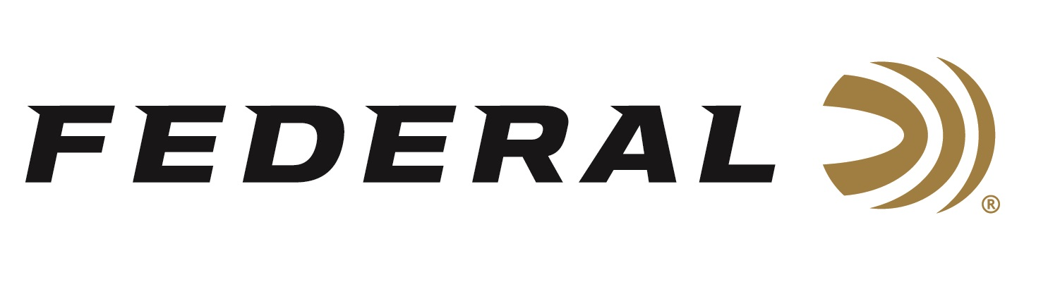
FOR IMMEDIATE RELEASE

Federal Continues as a Trailblazer of Conservation Sponsor of the Boone and Crockett Club

ANOKA, Minnesota – July 10, 2024 – Federal Ammunition is proud to continue supporting the Boone and Crockett Club through its Trailblazer in Conservation sponsorship as an Industry Sponsor.

Trailblazers in Conservation represents a commitment from industry partners and others that support the mutual interests of science-supported wildlife management and conservation, as well as hunter ethics and advocacy. Other program highlights include Outdoor Adventure Camps, Online Fair Chase and Hunter Ethics Courses, and Conservation Education Programs.

“Federal and our other ammunition brands of CCI, Remington, and Hevi-SHOT greatly value the Boone and Crockett Club’s extensive history of fighting for conservation and hunter rights, and their latest leadership in initiating the Poach & Pay project continues this tradition,” commented Federal’s Conservation Manager, Jon Zinnel. “We believe this commitment to finding the real cost of wildlife crimes and helping develop policies that will deter future crimes are essential to show the difference between law-abiding hunters and poachers clearly.”

The Boone and Crockett Conservation Education Program strives to offer perspectives that foster shared use of natural resources, conservation, sustainable development, and land stewardship to build a common ground for sustaining healthy ecosystems. The organization also facilitates online learning for new and seasoned hunters across the continent. Its fair chase subject matter experts, educators, and outdoors people coordinate and deliver world-class electronic learning experiences for many students annually.

The Boone and Crockett Club is the oldest conservation organization in the country and supports all big game hunting. Throughout its 134-year history, strategic partnerships, such as its sponsorship from Federal Ammunition, have contributed to many of the club's accomplishments. Learn more at www.boone-crockett.org.

Federal ammunition can be found at dealers nationwide. For more information on all products from Federal or to shop online, visit www.federalpremium.com.

Press Release Contact: JJ Reich
Senior Manager – Press Relations
E-mail: Ammunition@tkghunt.com

About Federal Ammunition
Federal, headquartered in Anoka, MN, is an ammunition brand of The Kinetic Group. From humble beginnings nestled among the lakes and woods of Minnesota, Federal Ammunition has evolved into one of the world's largest producers of sporting ammunition. Beginning in 1922, founding President Charles L. Horn paved the way for our success. Today, Federal carries on Horn's vision for quality products and services with the next generation of outdoorsmen and women. We maintain our position as experts in the science of ammunition production. Every day, we manufacture products to enhance our customers' shooting experience while partnering with the conservation organizations that protect and support our outdoor heritage. We offer thousands of options in our Federal Premium and Federal® lines, which makes us the most complete ammunition company in the business and provides our customers with a choice no matter their pursuit.

