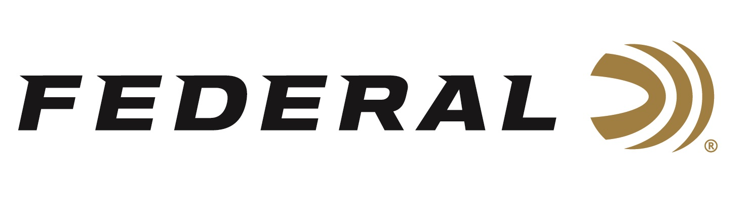

FOR IMMEDIATE RELEASE

Federal Ammunition Awarded United States Special Operations Contract for Mk316

ANOKA, Minnesota – July 22, 2024 – The United States Special Operations Command (USSOCOM) has awarded Federal Ammunition a one-year, $3.6M contract to supply SOCOM with 7.62x51mm rifle ammunition.

“This contract award for long-range rifle ammunition for SOCOM continues our long-standing support of the U.S. military,” said Federal’s President and CEO, Jason Vanderbrink. “This proven load is currently being produced for the U.S. Navy in a separate contract, validating our American manufacturing expertise and commitment to supplying the U.S. warfighter with the best products to protect and defend.”

The cartridge selected during the one-year contract is for the 7.62x51mm, 175-grain precision match rifle load. The ordering period is 12 months. Federal will produce the ammunition at its facility in Anoka, Minnesota.

“Federal’s performance reputation for our match ammunition has always been a competitive advantage shot after shot, lot to lot. MK316 Mod 0 fits in perfectly with Federal’s history of producing extremely accurate ammunition held to tight tolerances required by strict U.S. Military specifications,” continued Vanderbrink. “We are excited for this contract win. It validates the quality of our products, thoroughness of our testing procedures, and dedication to hard work from our American factory workers.”

Federal ammunition can be found at dealers nationwide. For more information on all products from Federal or to shop online, visit www.federalpremium.com.

Press Release Contact: JJ Reich
Senior Manager – Press Relations
E-mail: Ammunition@tkghunt.com

About Federal Ammunition
Federal, headquartered in Anoka, MN, is an ammunition brand of The Kinetic Group. From humble beginnings nestled among the lakes and woods of Minnesota, Federal Ammunition has evolved into one of the world's largest producers of sporting ammunition. Beginning in 1922, founding President Charles L. Horn paved the way for our success. Today, Federal carries on Horn's vision for quality products and services with the next generation of outdoorsmen and women. We maintain our position as experts in the science of ammunition production. Every day, we manufacture products to enhance our customers' shooting experience while partnering with the conservation organizations that protect and support our outdoor heritage. We offer thousands of options in our Federal Premium and Federal® lines, which makes us the most complete ammunition company in the business and provides our customers with a choice no matter their pursuit.

