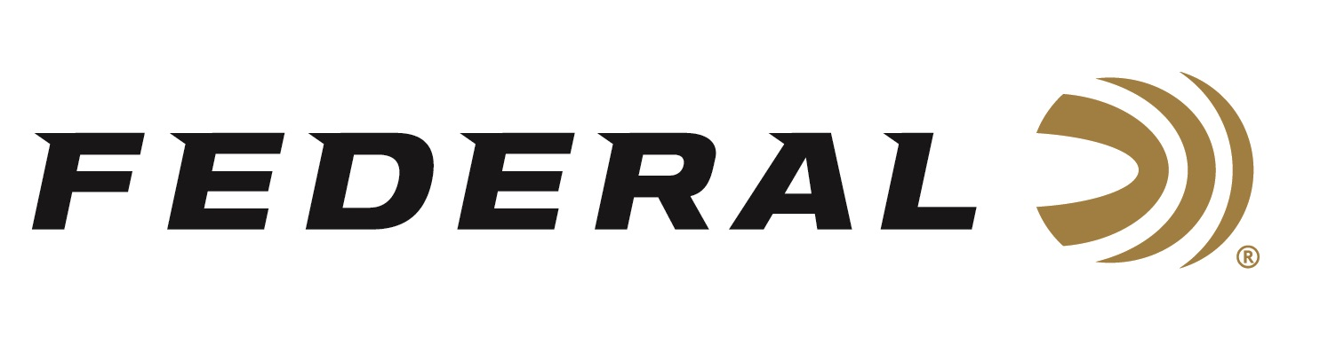

FOR IMMEDIATE RELEASE

Federal Ammunition is the Official Presenting Sponsor of the 2024 Delta Waterfowl Expo

ANOKA, Minnesota – July 19, 2024 – Federal Ammunition joins the 2024 Delta Waterfowl Duck Hunters Expo as the Presenting Sponsor. The event is July 26-28 at the Raising Cane’s River Center in Baton Rouge, Louisiana. Visitors to the Expo can stop by the Federal booth No. 105 to see the latest and greatest products from Federal.

“Federal is proud to be the presenting sponsor of this annual event for the third time in a row, as Delta Waterfowl is a vital conservation partner for us,” said Dan Compton, Federal’s Shotshell Product Director. “We are excited to see thousands of enthusiastic waterfowlers under one roof to talk about the shotshells we will have on display. And hearing their stories of success in the field drives us to continue to produce the highest quality American-made ammunition.”

Attendees can check out the latest waterfowl hunting gear, watch seminars from industry experts, participate in calling contests, raffles, and more. Attendees are encouraged to stop by Federal’s booth to register for a Boat Giveaway Sweepstakes. The prize package includes a Water Feather boat, a case of new Federal Premium Ultra Steel 12-gauge ammunition, a dozen Final Approach mallard decoys, and a new Federal Premium shotgun case.

Federal will release new products for waterfowlers in 2024, including the just-released Ultra Steel waterfowl product line, available in eight loads, plus Federal range bags, shell pouches, and gun cases.

Designed by hunters and shooters for the range, field, and blind, Federal’s new accessories include a full line of gun cases, shell pouches, and range bags. Built for convenience, protection, and accessibility, several styles are available in each product category.

Federal Premium Ultra Steel features the rear-opening FLITECONTROL FLEX wad and a zinc-plated steel payload. These 3-inch loads are available in various standard payloads, as well as stacked loads featuring two shot sizes.

Federal ammunition can be found at dealers nationwide. For more information on all products from Federal or to shop online, visit www.federalpremium.com.

Press Release Contact: JJ Reich
Senior Manager – Press Relations
E-mail: Ammunition@tkghunt.com

About Federal Ammunition
Federal, headquartered in Anoka, MN, is an ammunition brand of The Kinetic Group. From humble beginnings nestled among the lakes and woods of Minnesota, Federal Ammunition has evolved into one of the world's largest producers of sporting ammunition. Beginning in 1922, founding President Charles L. Horn paved the way for our success. Today, Federal carries on Horn's vision for quality products and services with the next generation of outdoorsmen and women. We maintain our position as experts in the science of ammunition production. Every day, we manufacture products to enhance our customers' shooting experience while partnering with the conservation organizations that protect and support our outdoor heritage. We offer thousands of options in our Federal Premium and Federal® lines, which makes us the most complete ammunition company in the business and provides our customers with a choice no matter their pursuit.

