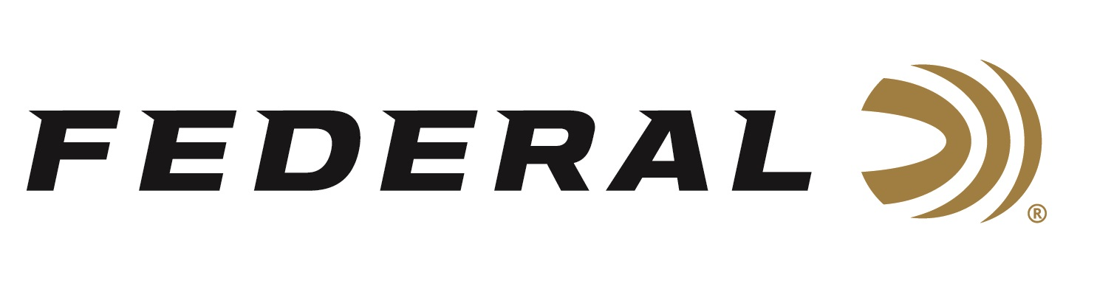
FOR IMMEDIATE RELEASE

Federal Continues Support of the Mule Deer Foundation at the Western Hunting and Conservation Expo

ANOKA, Minnesota – February 8, 2024 – Federal Ammunition is proud to continue its longtime support of the Mule Deer Foundation (MDF) by sponsoring the MDF Kick-Off Party for the Western Hunting and Conservation Expo, as well as committing as a general Gold Level Sponsor for the organization in 2024. The 2024 Western Hunting and Conservation Expo will be held February 15-18th in Salt Lake City, Utah. This is the largest hunting convention open to the public in the Western United States and expected to have more than 55,000 attendees over the four day show.

“The 2023 Hunt Expo raised nearly $14 million for wildlife conservation through show passes, auctions, tag sales, and other fundraisers, and we look forward to another energetic event this year,” said Jon Zinnel, Federal’s Senior Manager of Conservation. “Federal is excited to support the MDF, as the organization continues to stand strong for western hunters, healthy habitat, and all wildlife across the vast western landscapes.”

The MDF is dedicated to restoring, improving, and protecting mule deer and black-tailed deer and their habitat, with a focus on science and program efficiency. They are committed to sustaining western deer populations by ensuring quality habitat in the areas deer need on a daily, seasonal, and yearly basis. Learn more at: www.muledeer.org.

Federal Premium Terminal Ascent rifle ammunition is popular with big-game hunters targeting mule deer. Its bonded construction penetrates deep on close targets, while the patented Slipstream polymer tip initiates expansion at velocities 200 fps lower than comparable designs for long-range targets. The bullet’s long, sleek profile offers an extremely high ballistic coefficient, and its AccuChannel groove technology improves accuracy and minimizes drag. It’s available in a full selection of all-range hunting cartridges. In 2024, New Terminal Ascent line extensions will be 7mm PRC 170-grain and 300 PRC 210-grain.

Federal ammunition can be found at dealers nationwide and online. For more information on all products from Federal, visit www.federalpremium.com.

Press Release Contact: JJ Reich
Senior Manager – Press Relations
E-mail: VistaPressroom@VistaOutdoor.com
About Federal Ammunition
Federal, headquartered in Anoka, MN, is a brand of Vista Outdoor Inc., an outdoor sports and recreation company. From humble beginnings nestled among the lakes and woods of Minnesota, Federal Ammunition has evolved into one of the world's largest producers of sporting ammunition. Beginning in 1922, founding president, Charles L. Horn, paved the way for our success. Today, Federal carries on Horn's vision for quality products and service with the next generation of outdoorsmen and women. We maintain our position as experts in the science of ammunition production. Every day we manufacture products to enhance our customers' shooting experience while partnering with the conservation organizations that protect and support our outdoor heritage. We offer thousands of options in our Federal Premium and Federal® lines-it's what makes us the most complete ammunition company in the business and provides our customers with a choice no matter their pursuit.

