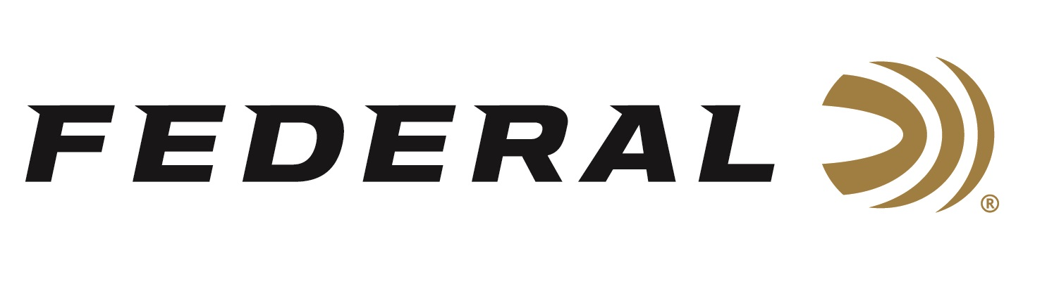

FOR IMMEDIATE RELEASE

**New Federal Premium Freight Train Copper Sabot Slugs Now Available**

**ANOKA, Minnesota – August 28, 2024 –** Hunters who want improved terminal performance and accuracy from their rifled-barrel shotguns can now load up with Federal’s Freight Train Copper Sabot Slugs. The Premium product line, designed for whitetail deer, black bears, and other big game targets, is now available at retail stores. Product details, videos, and availability can be found on the brand’s website:

[Freight Train Copper Sabot Slug Ammunition](https://www.federalpremium.com/shotshell/freight-train-copper-sabot-slug/)

Federal Premium Freight Train Copper is an all-new lineup of sabot slugs. A streamlined copper projectile and exclusive sabot design combine to help print tight groups at 200 yards through rifled barrels. A polymer tip and aerodynamic nose profile maximize downrange velocity and energy, while the externally skived nose cavity provides a dramatic expansion.

“One of the key factors to the accuracy of the new Federal Premium Freight Train is its exclusive sabot design, which improves overall accuracy through rifled barrels,” said Federal Shotshell Product Director Adam Moser. “The streamlined polypropylene tip in Federal Premium’s new Freight Train copper sabot slug also advances performance in several ways, improving accuracy, expansion, and downrange energy.”

The sabot aligns the slug within the bore and separates cleanly and consistently at the muzzle for peak accuracy. The deep, externally skived slug cavity provides consistent, aggressive expansion across a broad velocity range. The shotshells feature reliable primers and clean-burning propellant in 12- or 20-gauge options. They are packaged in 5-count boxes and meet lead-free ammunition requirements.

“The sleek exterior of the new Freight Train copper sabot slug contains several unique features that improve the bullet’s ballistic coefficient, boost penetration, and enhance its ability to expand on impact,” continued Moser. “The hollow point was also optimized so when the petals hinge back, they deliver a tight upset providing more penetration depth.”

**Part No. / Description / MSRP**

P151 FT / 12GA 3" 300GR FREIGHT TRAIN COPPER SABOT SLUG / $24.99

P152 FT / 12GA 2-3/4" 300GR FREIGHT TRAIN COPPER SABOT SLUG / $22.99

P209 FT / 20GA 3" 275GR FREIGHT TRAIN COPPER SABOT SLUG / $25.99

P208 FT / 20GA 2-3/4" 275GR FREIGHT TRAIN COPPER SABOT SLUG / $22.99

Federal ammunition is available at dealers nationwide. For more information on Federal products or to shop online, visit [www.federalpremium.com](http://www.federalpremium.com).

**Press Release Contact: JJ Reich**

Senior Manager – Press Relations

E-mail: [Ammunition@tkghunt.com](mailto:Ammunition@tkghunt.com)

**About Federal Ammunition**

Federal, headquartered in Anoka, MN, is an ammunition brand of The Kinetic Group. From humble beginnings nestled among the lakes and woods of Minnesota, Federal Ammunition has evolved into one of the world's largest producers of sporting ammunition. Beginning in 1922, founding President Charles L. Horn paved the way for our success. Today, Federal carries on Horn's vision for quality products and services with the next generation of outdoorsmen and women. We maintain our position as experts in the science of ammunition production. Every day, we manufacture products to enhance our customers' shooting experience while partnering with the conservation organizations that protect and support our outdoor heritage. We offer thousands of options in our Federal Premium and Federal® lines, which makes us the most complete ammunition company in the business and provides our customers with a choice no matter their pursuit.