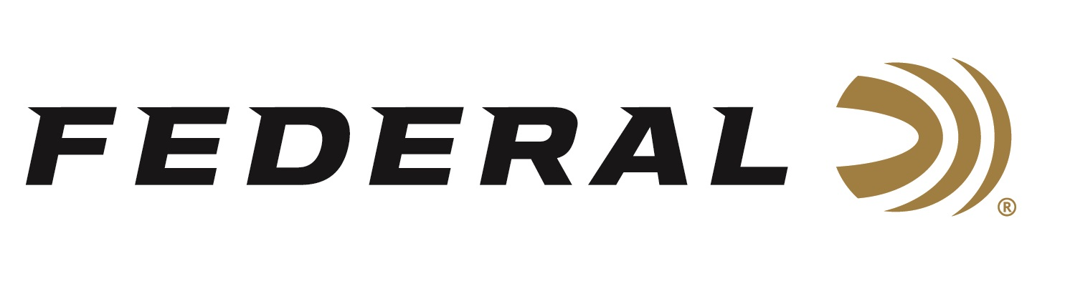

FOR IMMEDIATE RELEASE

Federal Wins Predator Xtreme 2024 Gold Award for Best Shotshells

ANOKA, Minnesota – March 6, 2024 – Federal has received the 2024 Gold Award in the category of Shotshells by the readers of Predator Xtreme. Hunters who read this magazine are extremely loyal to the products they use. These annual awards allow them to reveal what products they think are the absolute best.

“Federal has proven their Shotshells have phenomenal take down power in the field as well as taking down their competition and winning gold in the Predator Xtreme Readers' Choice Awards, now six years in a row,” said Predator Xtreme Publisher Derrick Nawrocki. “Predator Xtreme readers can be extremely picky on the gear they choose to use, but more importantly they are very loyal to the brands they love.”

Varmint Masters magazine was launch in 1994. It changed Its name around 2000 to Predator Xtreme. And, in 2024, is now celebrating 30 years of publication. Predator Xtreme continues to be the leading predator hunting brand today, and its popular Readers’ Choice Awards helps its audience select the most trusted brands available.

“A big congratulations goes out to all our American factory workers for a job well done. Federal is proud to be crowned gold by readers of Predator Xtreme again as we know their readers know their stuff,” said Federal Shotshell Product Director Dan Compton. “Federal has long been a fan favorite and continues to be the consistent brand predator hunters trust time and time again. We listen to our customers about what they need. Because of that, we are their top choice.”

Predator Xtreme polled its readership to find out their favorite gear; the products that really work. They then tallied the votes to determine the 2024 Readers' Choice Awards. The awards represent the best insider knowledge on products proven to work best for hunters nationwide. Reporting this knowledge helps their readers become better hunters and helps them spend their hunting gear money wisely.

Federal ammunition can be found at dealers nationwide and online. For more information on all products from Federal, visit www.federalpremium.com.

Press Release Contact: JJ Reich
Senior Manager – Press Relations
E-mail: Ammunition@tkghunt.com
About Federal Ammunition
Federal, headquartered in Anoka, MN, is an ammunition brand of The Kinetic Group. From humble beginnings nestled among the lakes and woods of Minnesota, Federal Ammunition has evolved into one of the world's largest producers of sporting ammunition. Beginning in 1922, founding president, Charles L. Horn, paved the way for our success. Today, Federal carries on Horn's vision for quality products and service with the next generation of outdoorsmen and women. We maintain our position as experts in the science of ammunition production. Every day we manufacture products to enhance our customers' shooting experience while partnering with the conservation organizations that protect and support our outdoor heritage. We offer thousands of options in our Federal Premium and Federal® lines-it's what makes us the most complete ammunition company in the business and provides our customers with a choice no matter their pursuit.

