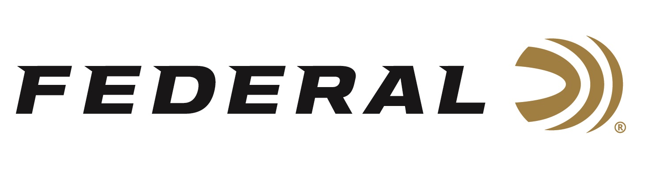

FOR IMMEDIATE RELEASE

Federal Announces All-New Freight Train Copper Tipped Sabot Slugs

ANOKA, Minnesota – January 22, 2024 – Federal Ammunition announces the addition of Freight Train Copper to its lineup of tipped sabot slugs in 12- and 20-gauge. The new product was recently announced and on display during the 2024 SHOT Show in Las Vegas, Nevada.

Freight Train Copper is an all-new lineup of tipped sabot slugs in 12-gauge, 300-grain, or 20-gauge, 275-grain. Both are available in 2-3/4- or 3-inch. The load’s streamlined copper projectile and exclusive sabot design combine to print excellent groups at 200 yards through rifled barrels. A polymer tip and aerodynamic nose profile maximize downrange energy, while the externally skived nose cavity provides dramatic expansion.

“Here at Federal, we are always looking for ways to improve our products to surpass customer needs and expectations. With Freight Train, we tailored the copper bullet design to improve expansion and penetration for optimal lethality on big game,” said Alex Schmieg, Federal's Senior Engineer for Shotshell Ammunition. “The all-new bullet has exceptional performance at all ranges giving hunters the confidence in thick timber or a 200-yard open shot across a field.”

Freight Train Copper tipped sabot slugs are packed in 5-count boxes with a Manufacturer’s Suggested Retail Price ranging from $21.99 to $24.99 depending on gauge and size.

Federal ammunition is available at dealers nationwide and online. For more information on all products from Federal, visit www.federalpremium.com.

Press Release Contact: JJ Reich
Senior Manager – Press Relations
E-mail: VistaPressroom@VistaOutdoor.com

About Federal Ammunition
Federal, headquartered in Anoka, MN, is a brand of Vista Outdoor Inc., an outdoor sports and recreation company. From humble beginnings nestled among the lakes and woods of Minnesota, Federal Ammunition has evolved into one of the world's largest producers of sporting ammunition. Beginning in 1922, founding president, Charles L. Horn, paved the way for our success. Today, Federal carries on Horn's vision for quality products and service with the next generation of outdoorsmen and women. We maintain our position as experts in the science of ammunition production. Every day we manufacture products to enhance our customers' shooting experience while partnering with the conservation organizations that protect and support our outdoor heritage. We offer thousands of options in our Federal Premium and Federal® lines-it's what makes us the most complete ammunition company in the business and provides our customers with a choice no matter their pursuit.

