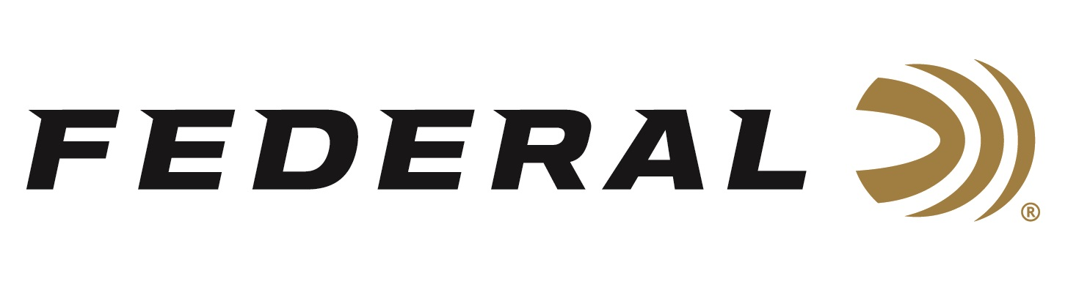
FOR IMMEDIATE RELEASE

Federal Will Announce New Handgun Ammunition at the 2024 SHOT Show

ANOKA, Minnesota – January 17, 2024 – Federal Ammunition is proud to announce new handgun ammunition options for 2024. Several new line extensions will be showcased and on display at the 2024 SHOT Show (Booth No. 11838), January 23–26 at the Venetian Expo and Caesars Forum in Las Vegas, Nevada. These new additions include new offerings in Federal’s Personal Defense Hydra-Shok Deep, Punch, and Champion training ammunition product lines.

Federal is giving the classic 32 Auto defensive cartridge a new life thanks to modern bullet technology. The new Personal Defense Hydra-Shok Deep 32 Auto 68-grain load maximizes the cartridge’s available energy to deliver penetration to critical depths through bare ballistics gelatin and heavy clothing.

The new Personal Defense Punch 25 Auto 45-grain Solid load is designed around the unique properties of the specific cartridge to provide caliber-optimized terminal performance. To that end, it features a deep-penetrating solid bullet design.

Federal Champion handgun loads provide accurate, target-grade performance. They’re loaded with quality brass and primers and are affordably priced for volume shooters. New additions include 380 Auto 95-grain and 38 Special 130-grain. Plus, an all-new, lighter recoil 30 Super Carry 90-grain load.

Attendees of the 2024 SHOT Show are encouraged to stop by Booth No. 11838 for a first-hand look at these new products and more. Information about the new products and line extensions can soon be found on Federal’s brand website.

For more information on all products from Federal, visit www.federalpremium.com.

Press Release Contact: JJ Reich
Senior Manager – Press Relations
E-mail: VistaPressroom@VistaOutdoor.com

About Federal Ammunition
Federal, headquartered in Anoka, MN, is a brand of Vista Outdoor Inc., an outdoor sports and recreation company. From humble beginnings nestled among the lakes and woods of Minnesota, Federal Ammunition has evolved into one of the world's largest producers of sporting ammunition. Beginning in 1922, founding president, Charles L. Horn, paved the way for our success. Today, Federal carries on Horn's vision for quality products and service with the next generation of outdoorsmen and women. We maintain our position as experts in the science of ammunition production. Every day we manufacture products to enhance our customers' shooting experience while partnering with the conservation organizations that protect and support our outdoor heritage. We offer thousands of options in our Federal Premium and Federal® lines-it's what makes us the most complete ammunition company in the business and provides our customers with a choice no matter their pursuit.

