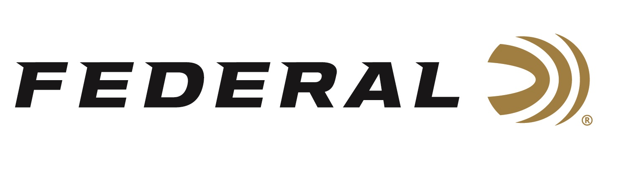

FOR IMMEDIATE RELEASE

Federal Announces New Prairie Storm Upland Loads

ANOKA, Minnesota – January 23, 2024 – Federal Ammunition announces the expansion of options for Prairie Storm upland hunting ammunition in 2024. The new loads usher in the all-new Prairie Storm Bismuth Blend product line, plus new additions to the classic Prairie Storm FS Lead existing lineup. These new products were recently announced and on display during the 2024 SHOT Show in Las Vegas, Nevada.

Prairie Storm Bismuth Blend is a new product line consisting of six loads. These upland loads feature Prairie Storm’s FLITECONTROL FLEX wad and Premium steel shot, No. 3 or 4, with the added performance boost of HEVI-Bismuth pellets, No. 5 or 6, alloyed and cast in Sweet Home, Oregon. The new product line is initially available in a total of six 12- and 20-gauge load options.

“HEVI-Bismuth is an industry standard for Bismuth pellets, which has made it the great equalizer on game birds when needing to meet non-toxic requirements,” said Josh Vickers, Federal's Research & Development Engineer. "Adding HEVI-Bismuth to the Prairie Storm family gives hunters a product that not only meets non-toxic requirements but also adds down range lethality due to increased pellet kinetic energy in part to density over steel alternatives.”

Trusted by upland hunters for more than a decade, Prairie Storm FS Lead upland loads utilize the rear-opening FLITECONTROL FLEX wad and a mixed payload of standard pellets and FLITESTOPPER lead pellets to produce full, consistent patterns through any choke. The four new product line additions include 12-gauge, 2 3/4-inch magnum loads in shot sizes 4, 5, or 6, and 28-gauge, 3-inch, 1-ounce No. 6.

“By extending the Prairie Storm lineup with new 12-gauge, 1-1/4-ounce, 2-3/4-inch offerings at 1,330 fps, we are able to give shooters a product with more traditional velocities that is softer on the shoulder, while keeping the benefits customers expect with Prairie Storm,” continued Vickers. “The soft-shooting 28-gauge is certainly trending high right now. By adding a 3-inch option, we were able to increase the payload weight to 1 ounce and couple it with our FLITECONTROL FLEX wad to ultimately increase lethality down range. Upland hunters will love it.”

Prairie Storm loads are packed in 25-count boxes with a Manufacturer’s Suggested Retail Price ranging from $34.99 to $47.99 depending on shot type, gauge, and size.

Federal ammunition is available at dealers nationwide and online. For more information on all products from Federal, visit www.federalpremium.com.

Press Release Contact: JJ Reich
Senior Manager – Press Relations
E-mail: VistaPressroom@VistaOutdoor.com

About Federal Ammunition
Federal, headquartered in Anoka, MN, is a brand of Vista Outdoor Inc., an outdoor sports and recreation company. From humble beginnings nestled among the lakes and woods of Minnesota, Federal Ammunition has evolved into one of the world's largest producers of sporting ammunition. Beginning in 1922, founding president, Charles L. Horn, paved the way for our success. Today, Federal carries on Horn's vision for quality products and service with the next generation of outdoorsmen and women. We maintain our position as experts in the science of ammunition production. Every day we manufacture products to enhance our customers' shooting experience while partnering with the conservation organizations that protect and support our outdoor heritage. We offer thousands of options in our Federal Premium and Federal® lines-it's what makes us the most complete ammunition company in the business and provides our customers with a choice no matter their pursuit.

