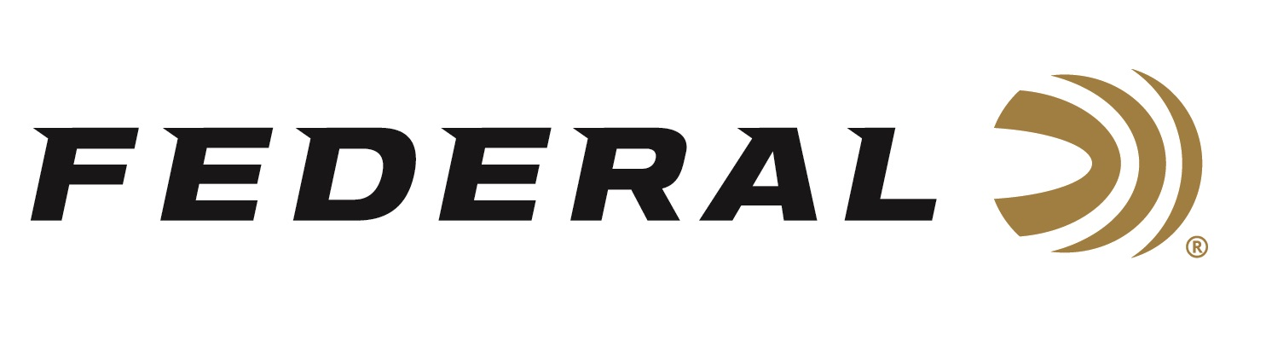

FOR IMMEDIATE RELEASE

Federal Will Announce New Centerfire Rifle Ammunition at the 2024 SHOT Show

ANOKA, Minnesota – January 18, 2024 – Federal Ammunition is proud to announce new centerfire rifle ammunition options for 2024. The all-new Fusion Tipped product line, plus several product line extensions will be showcased and on display at the 2024 SHOT Show (Booth No. 11838), January 23–26 at the Venetian Expo and Caesars Forum in Las Vegas, Nevada. These new product line additions include new Terminal Ascent, ELD-X, and HammerDown centerfire rifle loads, plus more.

The all-new Federal Fusion Tipped design offers the same great terminal performance as the original bonded soft points but with a polymer tip that increases ballistic coefficient, flattens trajectories, and boosts energy for better accuracy and extended effective range. Available in nine offerings ranging from 300 Blackout to 300 Win. Mag.

The bonded construction of Federal Premium Terminal Ascent penetrates deep on close targets, while the patented Slipstream polymer tip initiates expansion at extreme long-range targets too. The bullet’s long, sleek profile offers an extremely high ballistic coefficient, and its AccuChannel groove technology improves accuracy and minimizes drag. The new line extensions are 7mm PRC 170-grain and 300 PRC 210-grain.

Federal Premium ammunition loaded with ELD-X bullets delivers tag-filling terminal performance. The match-accurate, hard-hitting hunting projectile features an extremely high ballistic coefficient and a design that provides dynamic expansion at a wide range of velocities. The new line extensions are 6.5 PRC 143-grain and 7MM PRC 175-grain.

Velocities of Federal Premium HammerDown loads are customized to produce superior ballistics and terminal performance through lever-action rifle barrel lengths. The construction of the molecularly bonded soft point bullets has also been adjusted for the best accuracy and expansion at those velocities. The new line extension is 360 Buckhammer 220-grain.

Attendees of the 2024 SHOT Show are encouraged to stop by Booth No. 11838 for a first-hand look at these new products and more. Information about the new products and line extensions can soon be found on Federal’s brand website.

For more information on all products from Federal, visit www.federalpremium.com.

Press Release Contact: JJ Reich
Senior Manager – Press Relations
E-mail: VistaPressroom@VistaOutdoor.com

About Federal Ammunition
Federal, headquartered in Anoka, MN, is a brand of Vista Outdoor Inc., an outdoor sports and recreation company. From humble beginnings nestled among the lakes and woods of Minnesota, Federal Ammunition has evolved into one of the world's largest producers of sporting ammunition. Beginning in 1922, founding president, Charles L. Horn, paved the way for our success. Today, Federal carries on Horn's vision for quality products and service with the next generation of outdoorsmen and women. We maintain our position as experts in the science of ammunition production. Every day we manufacture products to enhance our customers' shooting experience while partnering with the conservation organizations that protect and support our outdoor heritage. We offer thousands of options in our Federal Premium and Federal® lines-it's what makes us the most complete ammunition company in the business and provides our customers with a choice no matter their pursuit.

