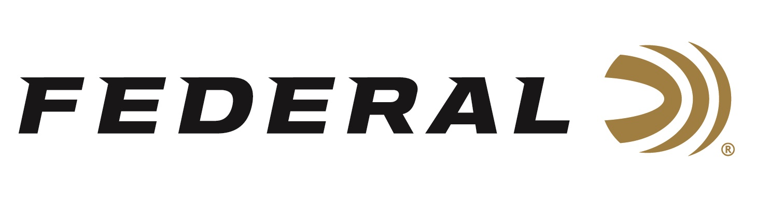
FOR IMMEDIATE RELEASE

Shooting Sports Retailer Honors Federal Ammunition with its 2023 Gold Award for Best Shotshells

ANOKA, Minnesota – April 11, 2024 – The readers of Shooting Sports Retailer recently awarded Federal with the 2023 Gold Award in the category of Shotshell Ammunition. The Readers’ Choice Awards are 100-percent reader driven and deliver unbiased views of what hunters, shooters, and reloaders seek out at retail stores.

“We listen to our customers about what they need. Because of that, we are their top choice,” said Federal Shotshell Product Manager Joshua Vickers. “For decades, retailers have enjoyed success selling our time-proven products, but also our newer releases such as Federal Action Shotgun as well. Every aspect of this new ammo has been designed to help competitors run their shotgun stages more efficiently and effectively.”

Action Shotgun features an overshot card and roll crimp that adds strength and rigidity to the mouth of the shell, allowing for improved cycling in both tube-fed and magazine-fed shotguns. The shell cup is made of brass-plated steel for reliable feeding and extraction to reduce the risk of jams.

Shooting Sports Retailer polled its readership to find out their favorite gear; the products that really work. They then tallied the votes to determine the 2024 Readers' Choice Awards.

“Retailers can be extremely picky on the gear they choose to sell, but more importantly they are very loyal to the brands that perform well in the marketplace,” said Shooting Sports Retailer Publisher Derrick Nawrocki. “Federal has proven their Shotshells have phenomenal power and performance in the field as well as for shooting sports competitions, and personal defense.”

Federal ammunition can be found at dealers nationwide and online. For more information on all products from Federal, visit www.federalpremium.com.

Press Release Contact: JJ Reich
Senior Manager – Press Relations
E-mail: Ammunition@tkghunt.com
About Federal Ammunition
Federal, headquartered in Anoka, MN, is an ammunition brand of The Kinetic Group. From humble beginnings nestled among the lakes and woods of Minnesota, Federal Ammunition has evolved into one of the world's largest producers of sporting ammunition. Beginning in 1922, founding president, Charles L. Horn, paved the way for our success. Today, Federal carries on Horn's vision for quality products and service with the next generation of outdoorsmen and women. We maintain our position as experts in the science of ammunition production. Every day we manufacture products to enhance our customers' shooting experience while partnering with the conservation organizations that protect and support our outdoor heritage. We offer thousands of options in our Federal Premium and Federal® lines-it's what makes us the most complete ammunition company in the business and provides our customers with a choice no matter their pursuit.

