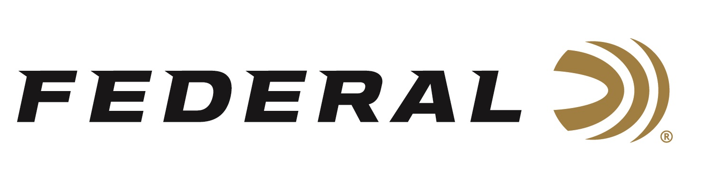

FOR IMMEDIATE RELEASE

Federal Will Announce New Shotshell Ammunition at the 2024 SHOT Show

ANOKA, Minnesota – January 12, 2024 – Federal Ammunition is proud to announce new shotshell ammunition options for 2024. Four all-new products and several product line extensions will be showcased and on display at the 2024 SHOT Show (Booth No. 11838), January 23–26 at the Venetian Expo and Caesars Forum in Las Vegas, Nevada. This ammunition includes new offerings in the Gold Medal, Heavyweight TSS, and Personal Defense Buckshot product lines. Plus, four all-new product lines: Freight Train, Hi-Bird Bismuth, Prairie Storm Bismuth Blend, and Ultra Steel.

Freight Train Copper is an all-new lineup of tipped sabot slugs in 12- or 20-gauge, and 2-3/4- or 3-inch. The load’s streamlined copper projectile and exclusive sabot design combine to print excellent groups at 200 yards through rifled barrels. A polymer tip and aerodynamic nose profile maximize downrange energy, while the externally skived nose cavity provides dramatic expansion.

Hi-Bird Bismuth, 12-gauge, No. 5 shotshells feature the same cellulose over-powder wad technology as original Hi-Bird Fiber Wad, but with a payload of 9.6 g/cc bismuth to meet nontoxic requirements. The pellets are 22 percent denser than steel, delivering more energy downrange, and the cellulose over-powder wad minimizes plastic left in the field.

Prairie Storm Bismuth Blend is a new product line consisting of six loads. These upland loads feature Prairie Storm’s FLITECONTROL FLEX wad and Premium steel shot, No. 3 or 4, with the added performance boost of HEVI-Bismuth pellets, No. 5 or 6, alloyed and cast in Sweet Home, Oregon.

Federal Premium Ultra Steel features the rear-opening FLITECONTROL FLEX wad with a payload of zinc-plated steel, producing extremely tight patterns for deadly performance. These 3-inch loads are available in a variety of standard payloads, as well as loads that feature two sizes of shot.

The new Gold Medal 12-gauge paper shotshells feature a 1-ounce payload, in shot sizes 7.5 and 8, that’s optimized for international FITASC competition. Like all Gold Medal Grand Paper loads, they feature a high-quality brass head, harder shot, and two-piece SoftCell wad design that reduces felt recoil and improves patterns.

The Heavyweight TSS Turkey new line extension is a 410 bore No. 7 load. The tungsten-alloy shot material’s 18 g/cc density is 56 percent more than lead, resulting in the highest pellet counts and the most energy at extreme range.

Federal Premium buckshot loads features the rear-braking FLITECONTROL wad to provide superior patterns. Their specialized payloads produce penetration fine-tuned to the needs of self-defense situations. The new addition is a 20-gauge, No. 2 Buck load.

Attendees of the 2024 SHOT Show are encouraged to stop by Booth No. 11838 for a first-hand look at these new products and more. Information about the new products and line extensions can soon be found on Federal’s brand website.

For more information on all products from Federal, visit www.federalpremium.com.

Press Release Contact: JJ Reich
Senior Manager – Press Relations
E-mail: VistaPressroom@VistaOutdoor.com

About Federal Ammunition
Federal, headquartered in Anoka, MN, is a brand of Vista Outdoor Inc., an outdoor sports and recreation company. From humble beginnings nestled among the lakes and woods of Minnesota, Federal Ammunition has evolved into one of the world's largest producers of sporting ammunition. Beginning in 1922, founding president, Charles L. Horn, paved the way for our success. Today, Federal carries on Horn's vision for quality products and service with the next generation of outdoorsmen and women. We maintain our position as experts in the science of ammunition production. Every day we manufacture products to enhance our customers' shooting experience while partnering with the conservation organizations that protect and support our outdoor heritage. We offer thousands of options in our Federal Premium and Federal® lines-it's what makes us the most complete ammunition company in the business and provides our customers with a choice no matter their pursuit.

