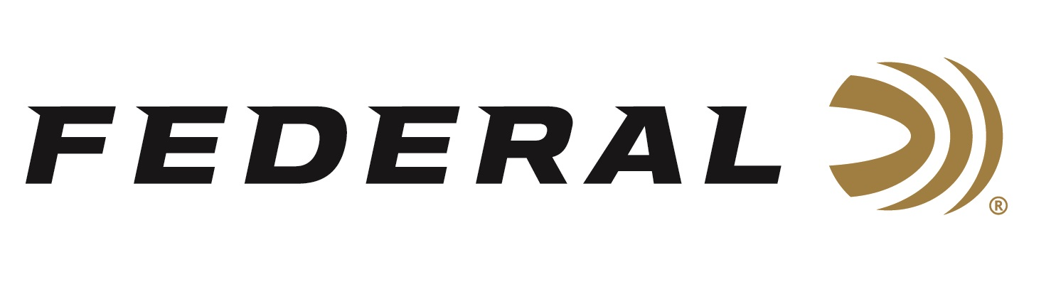

FOR IMMEDIATE RELEASE

**Federal Shooter Todd Jarrett Wins Gold at the IPSC Rifle World Shoot**

**ANOKA, Minnesota – August 14, 2024 –** Federal Ammunition congratulates sponsored shooter Todd Jarrett for winning Gold in the Super Senior category at the 2024 Rifle World Shoot, held in Oulu, Finland, July 30 - August 10. Jarrett also went on to help the Super Senior Team win the gold medal in the team competition, continuing the United States National Team’s tradition of excellence in this category. This year’s competition featured 735 competitors from dozens of countries.

“The IPSC Rifle World Shoot is a highly anticipated event that brings together top shooters from various countries to compete in a challenging and thrilling competition. We congratulate Jarrett for his big wins,” said Federal Ammunition’s Vice President of Marketing, Jason Nash. “With its rich history and tradition, the event showcases the pinnacle of shooting sports and serves as a platform for athletes to demonstrate their skills and sportsmanship.”

“The United States dominated the event in both the men’s and women’s divisions. This is my first world title in IPSC Rifle and my first IPSC rifle match. Previously, I have competed in many IPSC World Championship levels with a pistol over three decades, so it was a different experience,” said Jarrett. “My ammo was the Federal Premium 69-grain Sierra Match King bullets. My 600 rounds worked flawlessly during the match, including some shots out to 400 yards in some tricky Finland wind. I am looking forward to more International Rifle Championships using Federal ammo in the future.”

Federal ammunition can be found at dealers nationwide. For more information on all products from Federal or to shop online, visit [www.federalpremium.com](http://www.federalpremium.com).

**Press Release Contact: JJ Reich**

Senior Manager – Press Relations

E-mail: [Ammunition@tkghunt.com](mailto:Ammunition@tkghunt.com)

**About Federal Ammunition**

Federal, headquartered in Anoka, MN, is an ammunition brand of The Kinetic Group. From humble beginnings nestled among the lakes and woods of Minnesota, Federal Ammunition has evolved into one of the world's largest producers of sporting ammunition. Beginning in 1922, founding President Charles L. Horn paved the way for our success. Today, Federal carries on Horn's vision for quality products and services with the next generation of outdoorsmen and women. We maintain our position as experts in the science of ammunition production. Every day, we manufacture products to enhance our customers' shooting experience while partnering with the conservation organizations that protect and support our outdoor heritage. We offer thousands of options in our Federal Premium and Federal® lines, which makes us the most complete ammunition company in the business and provides our customers with a choice no matter their pursuit.