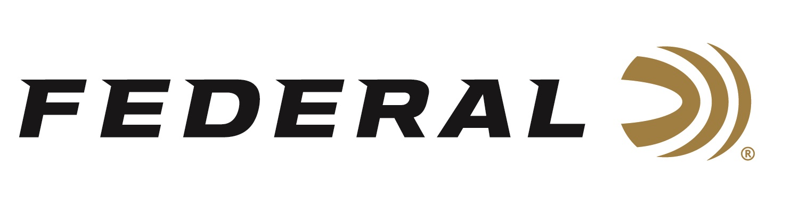

FOR IMMEDIATE RELEASE

NRA American Rifleman Magazine Honors Federal Premium Force X2 Shorty Shotshell with the “2024 Ammunition Product of the Year” Golden Bullseye Award

ANOKA, Minnesota – January 4, 2024 – The National Rifle Association’s (NRA) American Rifleman magazine awarded Federal Premium Force X2 Shorty Shotshell with the Golden Bullseye Award for 2024 Ammunition Product of the Year. Federal will be honored with the achievement during a special reception at the 2024 NRA Annual Meetings & Exhibits on May 16-19, 2024 in Dallas, Texas.

“We are truly honored by this prestigious award. We know that to qualify for consideration for a Golden Bullseye Award, the product must meet a variety of demanding criteria on design, function, value, and overall contribution to the shooting industry,” said Jesse Whiteside, Federal's Vice President of Product Management and Research & Development. “We are proud that our Force X2 Shorty delivered extreme reliability and performance that exceeded evaluators’ expectations during their rigorous field testing.”

Now in their 22nd year, the NRA Publications Golden Bullseye Awards acknowledge the finest products available in the shooting sports. The winners are selected by a seven-member committee consisting of editors, graphic designers, and veteran NRA Publications staff, representing more than a century of collective experience in the shooting and hunting industry.

The Force X2 Shorty is designed for use in firearms capable of cycling sub-length shotshells. This new 12-gauge 1 ¾-inch shotshell allows for higher magazine capacity with up to twice the wound channels over traditional buckshot pellets. The Force X2 Shorty design and cartridge size also delivers the benefit of manageable recoil for when repeatability is needed.

Force X2 Shorty packs a punch with six-pellet 00 copper plated segmenting buckshot. Each pellet is designed to split in half on impact. This allows the loads to have double the wound channels while reducing the risk of collateral damage from over penetration. Force X2 Shorty carries the same quality and performance expected by users of the standard-sized Force X2 shotshells (2 3/4-inch loads).

Federal ammunition can be found at dealers nationwide. For more information on all products from Federal, visit www.federalpremium.com.
Press Release Contact: JJ Reich
Senior Manager – Press Relations
E-mail: VistaPressroom@VistaOutdoor.com

About Federal Ammunition
Federal, headquartered in Anoka, MN, is a brand of Vista Outdoor Inc., an outdoor sports and recreation company. From humble beginnings nestled among the lakes and woods of Minnesota, Federal Ammunition has evolved into one of the world's largest producers of sporting ammunition. Beginning in 1922, founding president, Charles L. Horn, paved the way for our success. Today, Federal carries on Horn's vision for quality products and service with the next generation of outdoorsmen and women. We maintain our position as experts in the science of ammunition production. Every day we manufacture products to enhance our customers' shooting experience while partnering with the conservation organizations that protect and support our outdoor heritage. We offer thousands of options in our Federal Premium and Federal® lines-it's what makes us the most complete ammunition company in the business and provides our customers with a choice no matter their pursuit.

