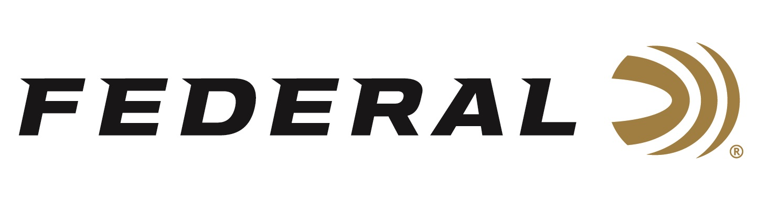

FOR IMMEDIATE RELEASE

Federal Ammunition’s All-New Fusion Tipped Now Available

ANOKA, Minnesota – August 6, 2024 – Federal Ammunition launches an all-new product line: Fusion Tipped. The design offers the same excellent terminal performance as the original bonded soft points but with a polymer tip that increases ballistic coefficient, flattens trajectories, and boosts energy for better accuracy and extended effective range. The all-new product line is offered in eight cartridge options and is now available at select dealers.

Fusion Tipped Rifle

“Following its initial release, Fusion ammunition quickly gained a reputation for its exceptional performance and reliability. Over the past 19 years, we have expanded Fusion into a large list of calibers and bullet weights, now totaling more than 50 product offerings across three different product families,” said Eric Miller, Federal’s Centerfire Product Line Manager. “This has allowed hunters and shooters to experience the benefits of bonded-core technology across a broad spectrum of firearms and game species. New Fusion Tipped is better than ever, and it will be this year’s new deer-camp champ.”

The all-new Fusion Tipped design offers the same excellent terminal performance as the original but with a polymer tip that reduces wind drift and drop and delivers more energy downrange. Paired with a skived nose cavity, the polymer tip also helps initiate consistent, lethal expansion. All this increases the ballistic coefficient, flattens trajectories, and boosts energy for better accuracy and extended effective range.

PART NO. / DESCRIPTION / MSRP
F65PRCTFS1 / 6.5 PRC 140 GR TIPPED FUSION / $66.99
F65CRDTFS1 / 6.5 CREEDMOOR 140 GR TIPPED FUSION / $58.99
F270TFS2 / 270 WIN 150 GR TIPPED FUSION / $52.99
F7RTFS2 / 7MM REM MAG 175 GR TIPPED FUSION / $70.99
F7PRCTFS2 / 7MM PRC 175 GR TIPPED FUSION / $72.99
F308TFS3 / 308 WIN 180 GR TIPPED FUSION / $52.99
F3006TFS3 / 30-06 SPRG 180 GR TIPPED FUSION / $52.99
F300WTFS3 / 300 WIN MAG 180 GR TIPPED FUSION / $72.99

Federal ammunition can be found at dealers nationwide. For more information on all products from Federal or to shop online, visit www.federalpremium.com.

Press Release Contact: JJ Reich
Senior Manager – Press Relations
E-mail: Ammunition@tkghunt.com

About Federal Ammunition
Federal, headquartered in Anoka, MN, is an ammunition brand of The Kinetic Group. From humble beginnings nestled among the lakes and woods of Minnesota, Federal Ammunition has evolved into one of the world's largest producers of sporting ammunition. Beginning in 1922, founding President Charles L. Horn paved the way for our success. Today, Federal carries on Horn's vision for quality products and services with the next generation of outdoorsmen and women. We maintain our position as experts in the science of ammunition production. Every day, we manufacture products to enhance our customers' shooting experience while partnering with the conservation organizations that protect and support our outdoor heritage. We offer thousands of options in our Federal Premium and Federal® lines, which makes us the most complete ammunition company in the business and provides our customers with a choice no matter their pursuit.

