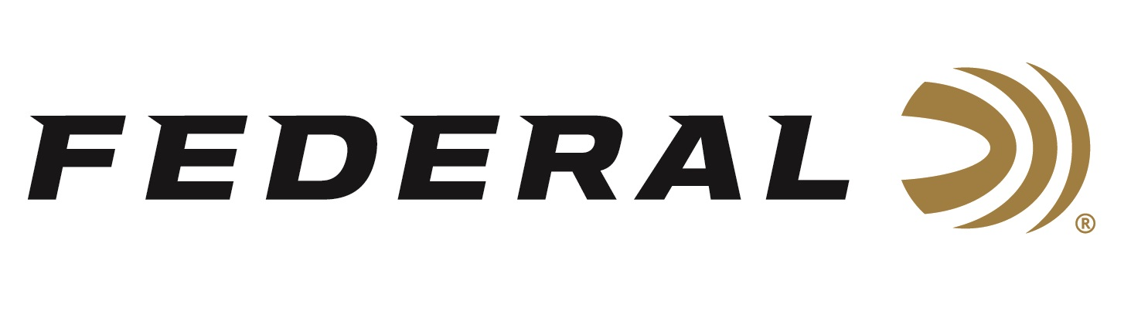
FOR IMMEDIATE RELEASE

Federal Ammunition Gold Medal Paper FITASC Loads Now Available

ANOKA, Minnesota – June 28, 2024 – Federal Ammunition adds two shotshell loads, optimized for FITASC competitions, to its popular Gold Medal Paper product line. These new loads are now available at select dealers.

“These new paper shotshells feature a 28-gram payload that’s ideal for international FITASC competition,” said Federal’s Shotshell Product Manager Josh Vickers. “Like all Gold Medal Paper loads, they feature a high-quality brass head, harder shot, and two-piece SoftCell wad design that reduces felt recoil and improves patterns.”

Features and benefits include an exclusive Federal Premium paper hull design;
two-piece wad utilizes SoftCell technology to decrease perceived recoil and produce more uniform patterns compared to one-piece designs; the brass head ensures flawless cycling and extraction; the lead shot is engineered for the optimum blend of hardness and density for even patterns and maximum downrange power.

The current Gold Medal Paper product lineup includes eleven cartridge options. The two new FITASC loads are 12-gauge, 2 ¾-inch, 28-gram, 1,330-feet-per-second at muzzle, 3 ½-dram in size No. 7 ½ or 8. They are available in 25-count boxes at an MSRP of $20.99.

FITASC is the international version of American sporting clays and is popular worldwide. Learn more at FITASC.

Federal is the number one choice for shotgun shells and manufactures products in America for all competitive and recreational disciplines. Learn more about Gold Medal Paper.

Federal ammunition can be found at dealers nationwide. For more information on all products from Federal or to shop online, visit www.federalpremium.com.

Press Release Contact: JJ Reich
Senior Manager – Press Relations
E-mail: Ammunition@tkghunt.com

About Federal Ammunition
Federal, headquartered in Anoka, MN, is an ammunition brand of The Kinetic Group. From humble beginnings nestled among the lakes and woods of Minnesota, Federal Ammunition has evolved into one of the world's largest producers of sporting ammunition. Beginning in 1922, founding President Charles L. Horn paved the way for our success. Today, Federal carries on Horn's vision for quality products and services with the next generation of outdoorsmen and women. We maintain our position as experts in the science of ammunition production. Every day, we manufacture products to enhance our customers' shooting experience while partnering with the conservation organizations that protect and support our outdoor heritage. We offer thousands of options in our Federal Premium and Federal® lines, which makes us the most complete ammunition company in the business and provides our customers with a choice no matter their pursuit.

