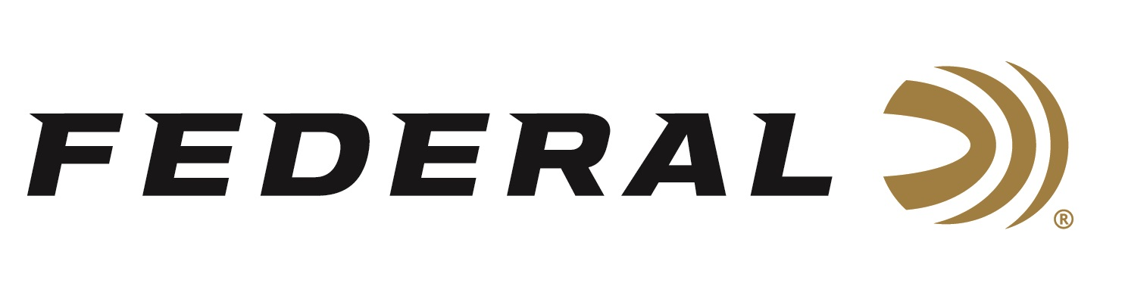

FOR IMMEDIATE RELEASE

On Target Magazine Honors Federal Premium Gold Medal CenterStrike with Editors’ Choice Award

ANOKA, Minnesota – January 30, 2024 – On Target magazine recently honored Federal Premium Gold Medal CenterStrike rifle ammunition with a 2023 Editors’ Choice Award, as part of the magazine’s 22nd annual awards program.

“These awards are reserved for the best-of-the-best new products which demonstrate outstanding technical achievement and/or represent an extraordinary value for the money,” said On Target Magazine Editor Ben Battles. “Gold Medal CenterStrike ammunition leverages an open tip match design, sleek profile, and extremely tight specifications for ultimate long-range accuracy and consistency.”

On Target is one of the leading publications in the shooting sports industry. Its staff tests and reviews guns, ammunition, and hunting products, and presents the results in a straightforward, no-nonsense format that provides all the information consumers need to make purchase decisions. The print version of On Target can be picked up free at any of the nearly 2,000 firearm and hunting product retailers nationwide that distribute the magazine.

The list of features for Federal Premium Gold Medal CenterStrike include: Precision-built OTM bullet design; High ballistic coefficient design; Held to Federal’s tightest specs for accuracy, pressure, and velocity; Gold Medal primers and brass; Specially formulated propellant; Available in 308 Win., 6.5 Creedmoor and 223 Rem; 20-round boxes; MSRP: $38.99-$49.99.

Learn more at: Gold Medal CenterStrike

Federal ammunition can be found at dealers nationwide and online. For more information on all products from Federal, visit www.federalpremium.com.

Press Release Contact: JJ Reich
Senior Communications Manager - Ammunition
E-mail: VistaPressroom@VistaOutdoor.com

About Federal Ammunition
Federal, headquartered in Anoka, MN, is a brand of Vista Outdoor Inc., an outdoor sports and recreation company. From humble beginnings nestled among the lakes and woods of Minnesota, Federal Ammunition has evolved into one of the world's largest producers of sporting ammunition. Beginning in 1922, founding president, Charles L. Horn, paved the way for our success. Today, Federal carries on Horn's vision for quality products and service with the next generation of outdoorsmen and women. We maintain our position as experts in the science of ammunition production. Every day we manufacture products to enhance our customers' shooting experience while partnering with the conservation organizations that protect and support our outdoor heritage. We offer thousands of options in our Federal Premium and Federal® lines-it's what makes us the most complete ammunition company in the business and provides our customers with a choice no matter their pursuit.

###

