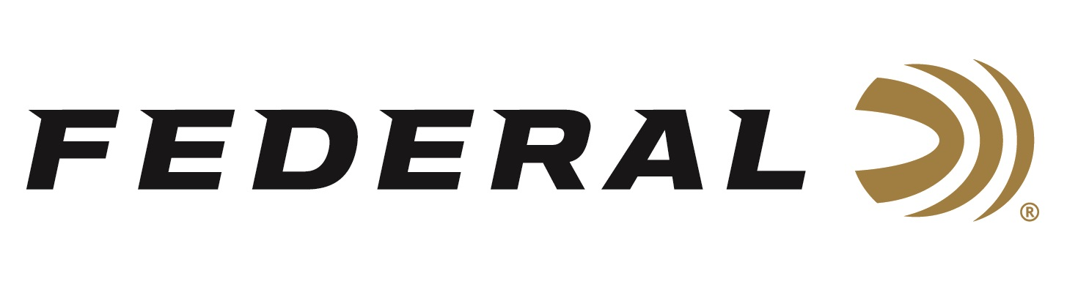

FOR IMMEDIATE RELEASE

**Team Federal’s Neilson Continues Momentous Run at Grand American**

**ANOKA, Minnesota – August 20, 2024 –** Federal Ammunition congratulates sponsored trap shooter Debbie Ohye-Neilson for another stellar Grand American performance. The 2024 ATA All-American and Lady II Captain won both the HOA and HAA Prelim and Grand at the 125th Grand American World Trapshooting Championship in the Lady II category. The competition took place at the World Shooting and Recreational Complex in Sparta, Ill. from July 31-August 10, 2024.

In all, Ohye-Neilson won 26 trophies at this year’s Grand American, which is the 41st

year she has been competing at the prestigious event. “This is the 25th year that I made the captaincy,” said Ohye-Neilson. “It’s the longest record existing and something I hope to add a few more years onto,” continued Ohye- Neilson. The veteran trapshooter loves the annual event as it draws the best of the best that she says elevates her game. “You got all the top people there and the bar is raised, and you just have to step up and do your best,” said Ohye-Neilsen.

Her entry into the shooting sports began in 1980 with the encouragement of her father, Kay Ohye, and she hasn’t looked back earning the distinguished honor of being inducted into the ATA Hall of Fame in 2005. She and her dad are the only father and daughter combination to be inducted into this select group. “If it wasn’t for him, his teachings, his knowledge, I wouldn’t be where I am at today… he had a big part of it,” said the Hall of Famer Ohye-Neilson.

For the Hall of Famer, she prefers Federal’s Top Gun in #8 for singles and doubles and relies on Federal Gold Medal Paper in #7.5 when shooting Handicap.

Other notable achievements from Team Federal include Scott Gens winning the HOA 2600 in the Sub-Vet category and long-time sponsored shooter Bob Munson from Howard Lake, MN winning the Sr-Vet Class Singles by shooting 200 straight.

Shotgunners on Team Federal use Federal Premium Gold Medal, High Over All and Top Gun shells, all designed to shoot smoothly and produce dense, uniform shot patterns that turn clay pigeons to dust.

Federal is the number one choice for shotgun shells and manufactures products in America for all competitive and recreational disciplines. See the full lineup, including the latest High Over All, at [www.federalpremium.com](http://www.federalpremium.com).

Federal ammunition can be found at dealers nationwide. For more information on all products from Federal or to shop online, visit [www.federalpremium.com](http://www.federalpremium.com).

**Press Release Contact: JJ Reich**

Senior Manager – Press Relations

E-mail: [Ammunition@tkghunt.com](mailto:Ammunition@tkghunt.com)

**About Federal Ammunition**

Federal, headquartered in Anoka, MN, is an ammunition brand of The Kinetic Group. From humble beginnings nestled among the lakes and woods of Minnesota, Federal Ammunition has evolved into one of the world's largest producers of sporting ammunition. Beginning in 1922, founding president, Charles L. Horn, paved the way for our success. Today, Federal carries on Horn's vision for quality products and service with the next generation of outdoorsmen and women. We maintain our position as experts in the science of ammunition production. Every day we manufacture products to enhance our customers' shooting experience while partnering with the conservation organizations that protect and support our outdoor heritage. We offer thousands of options in our Federal Premium and Federal® lines-it's what makes us the most complete ammunition company in the business and provides our customers with a choice no matter their pursuit.