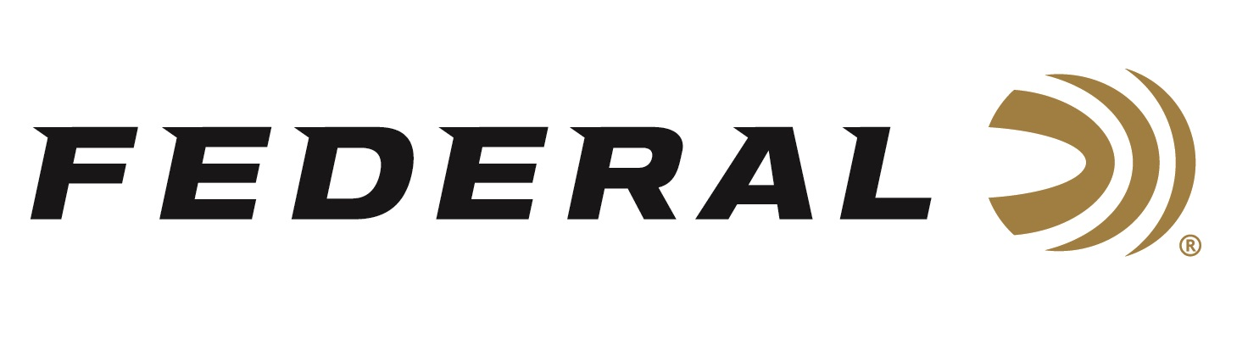

FOR IMMEDIATE RELEASE

**Federal’s Hydra-Shok Deep 32 Auto Received 2025 NRA Golden Bullseye Award**

**ANOKA, Minnesota –** **April 25, 2025 –** Federal’s Hydra-Shok Deep 32 Auto recently received the 2025 Golden Bullseye Award from the *NRA Women* publication for Gear of the Year. Federal was recognized and awarded during a special breakfast on Friday, April 25, at the 2025 NRA Annual Meetings & Exhibits in Atlanta, Georgia.

The caliber-tuned Hydra-Shok Deep bullet is specifically designed to maximize the performance of the 32 Auto cartridge. It features a more robust center post and a core design that hits optimum penetration depths through barriers encountered in self-defense situations. The bullet also features a specially formulated propellant and an extremely reliable primer.

[Personal Defense Hydra-Shok Deep 32 Auto](https://www.federalpremium.com/handgun/premium-personal-defense/personal-defense-hydra-shok-deep/11-P32HSD1.html)

“We are proud and grateful that the NRA Women publication recognized the innovation with their Gear of the Year award,” stated Nick Sachse, Product Management Director. “We launched this new 32 Auto option as part of our recent 'Your Partner in Protection' initiative. Effective self-defense requires ammunition to provide consistent expansion, optimum penetration, and superior terminal performance. We always strive to offer the best defense options possible for every popular gun choice. This means every individual can choose the ammo that best defines their purpose and preference. This award is proof that we are doing it right.”

The NRA Publications Golden Bullseye Awards acknowledge the finest products available for shooting sports. To qualify for consideration, a product must meet various demanding criteria on design, function, value, and overall contribution to the shooting industry.

Federal Ammunition products are available at dealers nationwide and online. For more information on all Federal products, visit [www.federalpremium.com](http://www.federalpremium.com).

**Press Release Contact:** JJ Reich

Senior Manager – Press Relations

E-mail: media@tkghunt.com

**About Federal Ammunition**

Federal, headquartered in Anoka, MN, is an ammunition brand of The Kinetic Group, owned by CSG, a globally diversified industrial group based in Prague (Czech Republic). From humble beginnings nestled among the lakes and woods of Minnesota, Federal Ammunition has evolved into one of the world's largest producers of sporting ammunition. In 1922, founding President Charles L. Horn paved the way for our success. Today, Federal carries on Horn's vision for quality products and services with the next generation of outdoorsmen and women. We maintain our position as experts in the science of ammunition production. Every day, Federal manufactures products to enhance our customers' shooting experience while partnering with the conservation organizations that protect and support our outdoor heritage. Federal offers thousands of options in our Federal Premium® and standard Federal® lines, which is what makes it the most complete ammunition company in the business and helps it provide customers with a choice no matter what the pursuit.