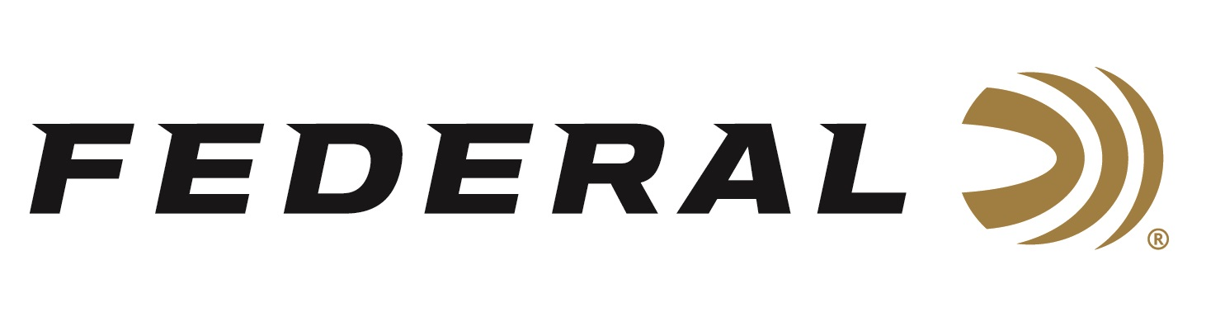

FOR IMMEDIATE RELEASE

**Federal Ammunition HammerDown 360 Buckhammer Now Shipping**

**ANOKA, Minnesota – September 12, 2024 –** Federal Ammunition’s HammerDown is the industry’s only ammunition product line truly designed for optimal cycling and overall performance in the time-tested, lever-action rifle platform. Federal successfully launched its HammerDown line in 2020, and today, the product lineup includes eight cartridge options. The latest 360 Buckhammer, 220 Grain Bonded Soft Point load, is now available at select dealers.

[HammerDown | Federal Premium](https://www.federalpremium.com/rifle/hammerdown/)

“The new 360 Buckhammer straight-wall cartridge is specially designed for lever-action rifles, making it a perfect match for our lever-action HammerDown product line, as straight-wall cartridges are now legal in more previously slug-only areas,” said Federal Ammunition Rifle Product Manager Eric Miller. “Its 358-caliber bullet provides ballistics and power like 30-30 Win. It’s a powerful and effective cartridge choice that is quickly gaining popularity with whitetail hunters.”

HammerDown's velocities are customized to produce superior ballistics and terminal performance through lever-action barrel lengths. The molecularly bonded soft point bullet construction provides the best accuracy and expansion at those velocities. The geometry of each round’s case, bullet, and cartridge ensures flawless cycling through tubular magazines and typical lever-action feeding systems.

“We are thrilled to add the 360 Buckhammer to our HammerDown lineup. This is the latest and greatest straight-wall cartridge that hunters and shooters are actively seeking out,” continued Miller. “One of the enhanced design features found in all HammerDown ammo is that we chamfered the front face of the case rim on all the nickel-plated cases. This removes any sharp edges to increase the reliability of feeding. All the benefits HammerDown delivers will greatly enhance your shooting experience.”

HammerDown is now offered in 45-70 Govt., 444 Marlin, 30-30 Win., 357 Magnum, 327 Federal and 44 Rem. Magnum, and .45 Colt. The new HammerDown 360 Buckhammer is packaged in 20-count boxes with an MSRP of $57.99.

Federal ammunition can be found at dealers nationwide. For more information on all products from Federal or to shop online, visit [www.federalpremium.com](http://www.federalpremium.com).

**Press Release Contact: JJ Reich**

Senior Manager – Press Relations

E-mail: [Ammunition@tkghunt.com](mailto:Ammunition@tkghunt.com)

**About Federal Ammunition**

Federal, headquartered in Anoka, MN, is an ammunition brand of The Kinetic Group. From humble beginnings nestled among the lakes and woods of Minnesota, Federal Ammunition has evolved into one of the world's largest producers of sporting ammunition. Beginning in 1922, founding President Charles L. Horn paved the way for our success. Today, Federal carries on Horn's vision for quality products and services with the next generation of outdoorsmen and women. We maintain our position as experts in the science of ammunition production. Every day, we manufacture products to enhance our customers' shooting experience while partnering with the conservation organizations that protect and support our outdoor heritage. We offer thousands of options in our Federal Premium and Federal® lines, which makes us the most complete ammunition company in the business and provides our customers with a choice no matter their pursuit.