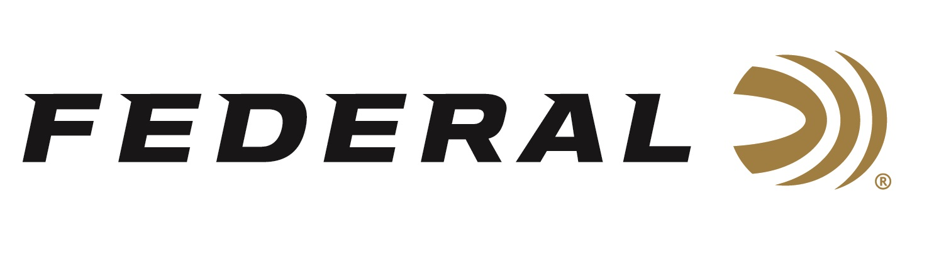
FOR IMMEDIATE RELEASE

Federal Ammunition HammerDown 45 Colt Now Available

ANOKA, Minnesota – June 6, 2024 – Federal Ammunition’s HammerDown is the industry’s only ammunition product line truly designed for optimal cycling and overall performance in the time-tested, lever-action rifle platform. Federal successfully launched Its HammerDown line in 2020, and today, the product lineup now includes seven cartridge options. The latest 45 Colt, 250 Grain load is now available at select dealers.

“We are thrilled to add the 45 Colt, designed for lever-action rifles, to our HammerDown lineup. This is another popular straight-wall cartridge that hunters and shooters are actively seeking out,” said Federal Ammunition Handgun Product Manager Chris Laack. “One of the enhanced design features found in all HammerDown ammo is that we chamfered the front face of the case rim on all the nickel-plated cases. This removes any sharp edges to increase the reliability of feeding. All the benefits HammerDown delivers will greatly enhance your shooting experience.”

The velocities of HammerDown are customized to produce superior ballistics and terminal performance through lever-action barrel lengths. The construction of the molecularly bonded soft point bullets has also been adjusted for the best accuracy and expansion at those velocities. The geometry of each round’s case, bullet and cartridge ensures flawless cycling through tubular magazine and typical lever-action feeding systems.

HammerDown is now offered in 45-70 Govt., 444 Marlin, 30-30 Win., 357 Magnum, 327 Federal and 44 Rem. Magnum, and .45 Colt.

Learn more about HammerDown.

Federal ammunition can be found at dealers nationwide. For more information on all products from Federal or to shop online, visit www.federalpremium.com.

Press Release Contact: JJ Reich
Senior Manager – Press Relations
E-mail: Ammunition@tkghunt.com

About Federal Ammunition
Federal, headquartered in Anoka, MN, is an ammunition brand of The Kinetic Group. From humble beginnings nestled among the lakes and woods of Minnesota, Federal Ammunition has evolved into one of the world's largest producers of sporting ammunition. Beginning in 1922, founding President Charles L. Horn paved the way for our success. Today, Federal carries on Horn's vision for quality products and services with the next generation of outdoorsmen and women. We maintain our position as experts in the science of ammunition production. Every day, we manufacture products to enhance our customers' shooting experience while partnering with the conservation organizations that protect and support our outdoor heritage. We offer thousands of options in our Federal Premium and Federal® lines, which makes us the most complete ammunition company in the business and provides our customers with a choice no matter their pursuit.

