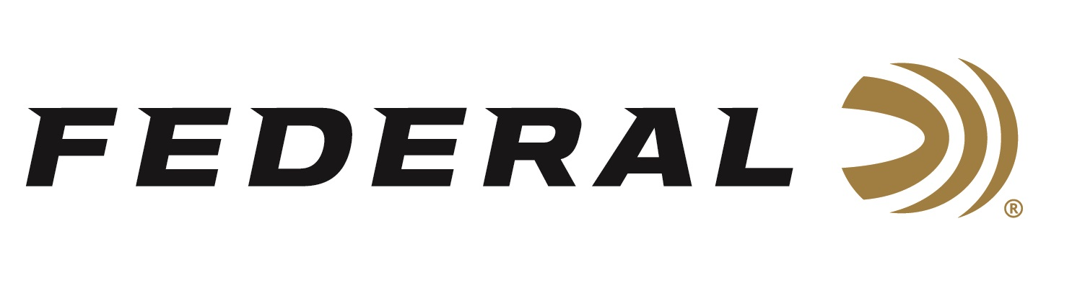

FOR IMMEDIATE RELEASE

Federal Ammunition’s Vincent Hancock Qualifies for a Spot on the
USA Shooting Men’s Skeet Team

ANOKA, Minnesota – March 21, 2024 – Federal Ammunition congratulates sponsored shooter Vincent Hancock for qualifying for a spot on the 2024 USA Shooting Men’s Skeet team, headed to the summer games in Paris. Hancock’s performance during the Shotgun Selection Match, March 11-17 at the Tucson Trap and Skeet Club in Tucson, Arizona, was stellar breaking 250 out of 250 targets.

“I’m incredibly grateful for this opportunity to continue doing what I love and to compete once again,” said Hancock. “I’m looking forward to competing in the biggest skeet event in the world. I thank my sponsors, which includes Federal Ammunition, for being my partners and providing the gear needed to succeed.”

Hancock is now a 5-time participant at the games (2008, 2012, 2016, 2020, 2024); 3-time gold medalist; 2023 Pan American Games Champion; and has many more major championships to his credit, including more than 24 International medals.

“Vincent has set a high bar for skeet shooting in our country over the last two decades, and he will be an excellent representative of the U.S.A. in Paris,” said Federal Ammunition’s Vice President of Marketing Jason Nash. “This means he could become the sixth athlete ever—and the first in shooting sports—to win the same individual event four times placing him in rarified air. We are eager and excited to see him shoot for yet another gold medal.”

Hancock relies on Federal Premium Gold Medal Paper Shotshells. The look, feel and performance of these shotshells have made them the favorite of the most serious clay target shooters. They feature a high-quality brass head, harder shot, and two-piece SoftCell wad design that reduces felt recoil and improves patterns. Learn more: Gold Medal Paper.

Federal is the number one choice for shotgun shells and manufactures products in America for all competitive and recreational disciplines. See the full lineup at www.federalpremium.com.

Federal ammunition can be found at dealers nationwide. For more information on all products from Federal or to shop online, visit www.federalpremium.com. To support America’s shooting team, visit www.usashooting.org to find out more.

Photo courtesy Josh Schave/USA Shooting.

Press Release Contact: JJ Reich
Senior Manager – Press Relations
E-mail: Ammunition@tkghunt.com

About Federal Ammunition
Federal, headquartered in Anoka, MN, is an ammunition brand of The Kinetic Group. From humble beginnings nestled among the lakes and woods of Minnesota, Federal Ammunition has evolved into one of the world's largest producers of sporting ammunition. Beginning in 1922, founding president, Charles L. Horn, paved the way for our success. Today, Federal carries on Horn's vision for quality products and service with the next generation of outdoorsmen and women. We maintain our position as experts in the science of ammunition production. Every day we manufacture products to enhance our customers' shooting experience while partnering with the conservation organizations that protect and support our outdoor heritage. We offer thousands of options in our Federal Premium and Federal® lines-it's what makes us the most complete ammunition company in the business and provides our customers with a choice no matter their pursuit.

