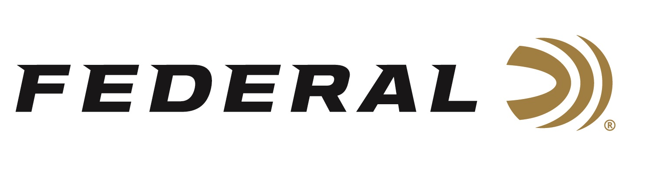

FOR IMMEDIATE RELEASE

Federal Ammunition’s Vincent Hancock Collects More ISSF World Cup Medals

ANOKA, Minnesota – February 14, 2024 – Federal Ammunition congratulates sponsored shooter Vincent Hancock, a three-time Olympic champion, on bringing home two more ISSF World Cup medals from Morrocco. Hancock won silver in Men’s Skeet and gold in the Skeet Mixed Team event in Rabat, Morrocco, during the shotgun world cup event held February 4-13, 2024.

In the Men’s Skeet competition, Hancock qualified in sixth place to make the finals. During the medal competition, Hancock climbed the ladder with an excellent performance before being bested by Italy’s Tammaro Cassandro who missed just one target out of 60 in the finals.

In the Mixed Team Skeet competition, Hancock and his teammate missed just one combined target out of 150 to qualify for the gold medal match. Hancock continued his perfection in the finals shooting clean leading the American team over a team from Georgia by five targets to claim the gold medal. “Another great international performance by Vincent,” says Jason Nash, Federal’s Vice President of Marketing. “Vincent is a champion, and we look forward to the Paris selection matches in Tucson, AZ coming in March,” says Nash.

Federal is the number one choice for shotgun shells and manufactures products in America for all competitive and recreational disciplines. See the full lineup, including the latest High Over All, at www.federalpremium.com.

Federal ammunition can be found at dealers nationwide. For more information on all products from Federal or to shop online, visit www.federalpremium.com. To support America’s shooting team, visit www.usashooting.org to find out more.

Photo credit: Andrea Caroppo

Press Release Contact: JJ Reich
Senior Manager – Press Relations
E-mail: VistaPressroom@VistaOutdoor.com

About Federal Ammunition
Federal, headquartered in Anoka, MN, is a brand of Vista Outdoor Inc., an outdoor sports and recreation company. From humble beginnings nestled among the lakes and woods of Minnesota, Federal Ammunition has evolved into one of the world's largest producers of sporting ammunition. Beginning in 1922, founding president, Charles L. Horn, paved the way for our success. Today, Federal carries on Horn's vision for quality products and service with the next generation of outdoorsmen and women. We maintain our position as experts in the science of ammunition production. Every day we manufacture products to enhance our customers' shooting experience while partnering with the conservation organizations that protect and support our outdoor heritage. We offer thousands of options in our Federal Premium and Federal® lines-it's what makes us the most complete ammunition company in the business and provides our customers with a choice no matter their pursuit.

