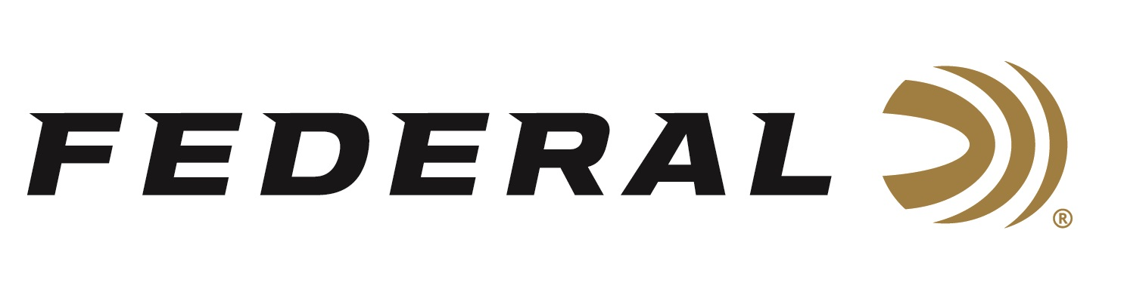
FOR IMMEDIATE RELEASE

Federal Ammunition Hydra-Shok Deep 32 Auto Now Available

ANOKA, Minnesota – June 17, 2024 – Federal Ammunition adds a 32 Auto, 68 Grain load to its popular Personal Defense Hydra-Shok Deep product line. This new load is now available at select dealers.

“The Hydra-Shok Deep bullet design works extremely well in cartridges with limited available energy,” said Federal Handgun Product Manager Chris Laack. “The bullet’s controlled expansion provides an optimal balance between upset size and penetration depth. This allows us to achieve some of the best terminal performance ever offered in the 32 Auto cartridge.”

Federal Premium Hydra-Shok has proven itself for self-defense since 1989. Hydra-Shok Deep builds on the time-tested platform with design improvements that better meet modern performance measurements. The bullet features a more robust center post and a core design penetrating to optimal depths through the barriers most commonly encountered in self-defense situations. The Personal Defense loads also tout specially formulated propellant and extremely reliable primers.

Federal successfully launched Its Personal Defense Hydra-Shok Deep line in 2018, and today, the product lineup includes six cartridge options. The new Hydra-Shok Deep 32 Auto, 68 Grain load is available in 20-count boxes at an MSRP of $35.99.

Learn more about Personal Defense Hydra-Shok Deep.

Federal ammunition can be found at dealers nationwide. For more information on all products from Federal or to shop online, visit www.federalpremium.com.

Press Release Contact: JJ Reich
Senior Manager – Press Relations
E-mail: Ammunition@tkghunt.com

About Federal Ammunition
Federal, headquartered in Anoka, MN, is an ammunition brand of The Kinetic Group. From humble beginnings nestled among the lakes and woods of Minnesota, Federal Ammunition has evolved into one of the world's largest producers of sporting ammunition. Beginning in 1922, founding President Charles L. Horn paved the way for our success. Today, Federal carries on Horn's vision for quality products and services with the next generation of outdoorsmen and women. We maintain our position as experts in the science of ammunition production. Every day, we manufacture products to enhance our customers' shooting experience while partnering with the conservation organizations that protect and support our outdoor heritage. We offer thousands of options in our Federal Premium and Federal® lines, which makes us the most complete ammunition company in the business and provides our customers with a choice no matter their pursuit.

