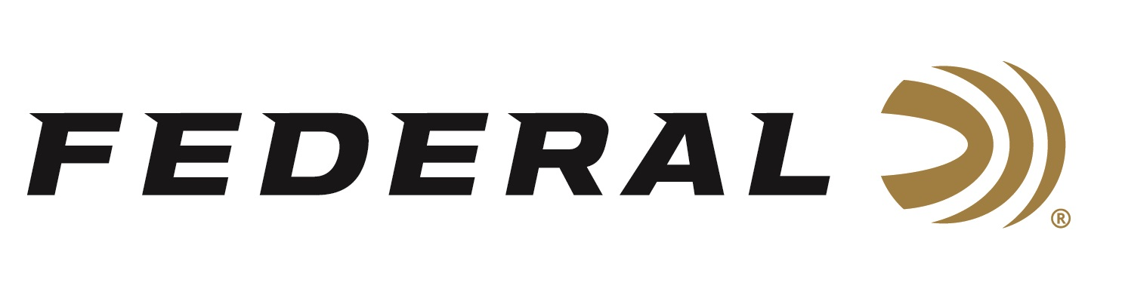

FOR IMMEDIATE RELEASE

Federal Ammunition’s Derrick Mein Earns a Spot on the
USA Shooting Men’s Trap Team

ANOKA, Minnesota – March 18, 2024 – Federal Ammunition congratulates sponsored shooter Derrick Mein for winning his spot on the 2024 USA Shooting Men’s Trap team, headed to the summer Olympic games in Paris. Mein’s performance during the Shotgun Selection Match, March 11-17 at the Tucson Trap and Skeet Club in Tucson, Arizona, was exceptional.

“I had a good week! I was happy that I got to share this victory with my family. It’s always good to have my wife, daughter and parents by my side while competing,” said Mein. “Shooting 250 targets alongside everyone else that is in the running to make the team makes it feel like a 250 target shoot-off. That can test anyone’s mental fortitude.”

The Olympic games in Paris will be Mein’s second appearance on the world’s greatest stage. Mein was 24th in his Olympic debut in Tokyo and placed 13th with Kayle Browning in the mixed-gender team event. Derrick Mein won the World Championship in 2022 and many other titles since Tokyo. He is eager to get back into the Olympic arena.

“I’m most excited that my family will have the opportunity to travel to Paris this time around. In Tokyo, because of Covid, none of my family got the opportunity to attend. And it’s also a chance for some redemption, I didn’t feel like I had a good performance,” stated Mein. “Between now and the competition, I will be traveling to the three World Cup events as well as spending time with my coaches and team training to prep for the games. I’m extremely excited about this opportunity.”

Federal is the number one choice for shotgun shells and manufactures products in America for all competitive and recreational disciplines. See the full lineup, including the latest High Over All, at www.federalpremium.com.

Federal ammunition can be found at dealers nationwide. For more information on all products from Federal or to shop online, visit www.federalpremium.com. To support America’s shooting team, visit www.usashooting.org to find out more.

Photo courtesy of USA Shooting.

Press Release Contact: JJ Reich
Senior Manager – Press Relations
E-mail: Ammunition@tkghunt.com

About Federal Ammunition
Federal, headquartered in Anoka, MN, is an ammunition brand of The Kinetic Group. From humble beginnings nestled among the lakes and woods of Minnesota, Federal Ammunition has evolved into one of the world's largest producers of sporting ammunition. Beginning in 1922, founding president, Charles L. Horn, paved the way for our success. Today, Federal carries on Horn's vision for quality products and service with the next generation of outdoorsmen and women. We maintain our position as experts in the science of ammunition production. Every day we manufacture products to enhance our customers' shooting experience while partnering with the conservation organizations that protect and support our outdoor heritage. We offer thousands of options in our Federal Premium and Federal® lines-it's what makes us the most complete ammunition company in the business and provides our customers with a choice no matter their pursuit.

