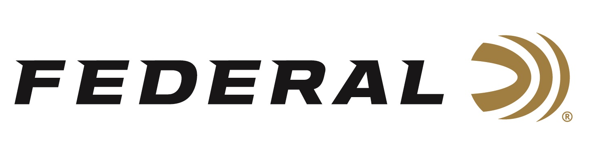

FOR IMMEDIATE RELEASE

***NRA Women* Names Federal’s Hydra-Shok Deep 32 Auto as a 2025 Golden Bullseye Award Winner**

**ANOKA, Minnesota –** **January 8, 2025 –** Federal’s Hydra-Shok Deep 32 Auto has been honored with the 2025 *NRA Women* Gear of the Year Golden Bullseye Award. Federal will be recognized in association with the award during a special breakfast on Friday, April 25, at the 2025 NRA Annual Meetings & Exhibits in Atlanta, Georgia.

“Hydra-Shok Deep bullet designs have proven optimal for cartridges with limited energy,” stated Chris Laack, Federal’s Handgun Ammunition Product Manager. “As we discovered with the .380 Auto, Hydra-Shok Deep maximizes the potential of .32 Auto. Defense with a handgun isn’t one size fits all. Different shooters have different needs driving their firearm selection. It’s critical that we offer the best defense options possible for every popular gun choice, including those chambered in 32 Auto. We are proud and grateful that the NRA Women publication recognized that with their Gear of the Year award.”

The Hydra-Shok Deep bullet, optimized for the 32 Auto cartridge, features a robust center post and a core design. These enable the bullet to penetrate to optimal depths through the barriers most commonly encountered in self-defense situations. It also features specially formulated propellant, an extremely reliable primer, and more.

Learn more at [Personal Defense Hydra-Shok Deep 32 Auto](https://www.federalpremium.com/handgun/premium-personal-defense/personal-defense-hydra-shok-deep/11-P32HSD1.html).

The NRA Publications Golden Bullseye Awards acknowledge the finest products available for shooting sports. To qualify for consideration, a product must meet various demanding criteria on design, function, value, and overall contribution to the shooting industry.

Federal Ammunition products are available at dealers nationwide and online. For more information on all Federal products, visit [www.federalpremium.com](http://www.federalpremium.com).

**Press Release Contact:** JJ Reich

Senior Manager – Press Relations

E-mail: media@tkghunt.com

**About Federal Ammunition**

Federal, headquartered in Anoka, MN, is an ammunition brand of The Kinetic Group, owned by CSG, a globally diversified industrial group based in Prague (Czech Republic). From humble beginnings nestled among the lakes and woods of Minnesota, Federal Ammunition has evolved into one of the world's largest producers of sporting ammunition. In 1922, founding President Charles L. Horn paved the way for our success. Today, Federal carries on Horn's vision for quality products and services with the next generation of outdoorsmen and women. We maintain our position as experts in the science of ammunition production. Every day, Federal manufactures products to enhance our customers' shooting experience while partnering with the conservation organizations that protect and support our outdoor heritage. Federal offers thousands of options in our Federal Premium® and standard Federal® lines, which is what makes it the most complete ammunition company in the business and helps it provide customers with a choice no matter what the pursuit.