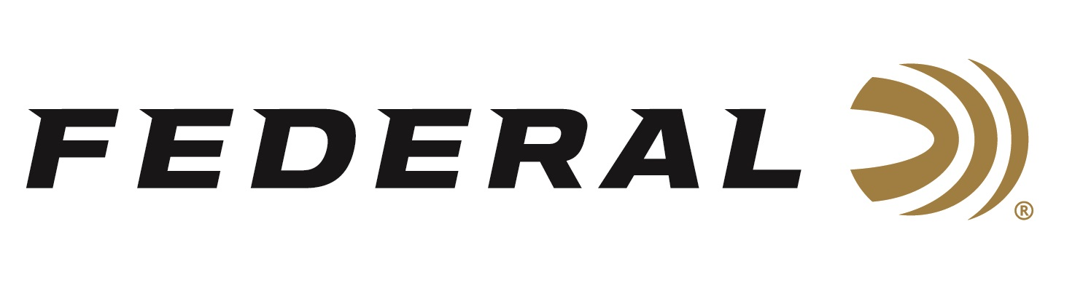
FOR IMMEDIATE RELEASE

Federal Ammunition is Proud to Sponsor NWTF’s 2024
Convention and Sport Show

ANOKA, Minnesota – February 7, 2024 – Federal Ammunition is the title sponsor of the Hunting Heritage Breakfast on Friday February 16 at the National Wild Turkey Federation’s (NWTF) 48th Annual Convention and Sport Show. The 2024 NWTF Convention will be held February 14-18, 2023 in Nashville, Tennessee. Federal Premium Ammunition also continues as a Gobbler Sponsor of the overall event.

“This big event is something any turkey hunter will not want to miss,” said Federal's Shotshell Product Line Manager Joshua Vickers. “It’s great to come together to celebrate conservation successes and also look to the future of wild turkey conservation and the great things still to come for the NWTF. It’s also an ideal time to showcase our turkey-hunting specific products that many diehard hunters love and rely on year after year.”

Federal Ammunition and the National Wild Turkey Federation have been working hand in hand for decades. The company has participated at every NWTF convention and has hosted the Conservation Breakfast for 41 years. Federal Ammunition is one of the five longest-running sponsors of the NWTF.

“Federal and NWTF have had a longstanding relationship which has continued over four decades. We look forward to many more years of working together,” continued Vickers. “Visiting with NWTF members from across the country reaffirms the passion and drive of their membership to support conservation of all species.”

Federal's turkey shotshells offer performance in a wide variety of options. Their current product families include Federal Premium Grand Slam, 3rd Degree with TSS, HEAVYWEIGHT TSS and Custom Shop TSS turkey loads. New for 2024, Federal’s Heavyweight TSS Turkey ammo includes a new line extension which is a 410 bore No. 7 load. The tungsten-alloy shot material’s 18 g/cc density is 56 percent more than lead, resulting in the highest pellet counts and the most energy at extreme range.

Attendees of the NWTF’s 2024 Convention and Sport Show are encouraged to stop by Federal’s booth No. 1113 to talk with Federal’s enthusiastic staff about the perfect ammunition for any upcoming turkey hunting adventure.

Federal ammunition can be found at dealers nationwide or online. For more information on all products from Federal, visit www.federalpremium.com.

Press Release Contact: JJ Reich
Senior Manager – Press Relations
E-mail: VistaPressroom@VistaOutdoor.com

About Federal Ammunition
Federal, headquartered in Anoka, MN, is a brand of Vista Outdoor Inc., an outdoor sports and recreation company. From humble beginnings nestled among the lakes and woods of Minnesota, Federal Ammunition has evolved into one of the world's largest producers of sporting ammunition. Beginning in 1922, founding president, Charles L. Horn, paved the way for our success. Today, Federal carries on Horn's vision for quality products and service with the next generation of outdoorsmen and women. We maintain our position as experts in the science of ammunition production. Every day we manufacture products to enhance our customers' shooting experience while partnering with the conservation organizations that protect and support our outdoor heritage. We offer thousands of options in our Federal Premium and Federal® lines-it's what makes us the most complete ammunition company in the business and provides our customers with a choice no matter their pursuit.

