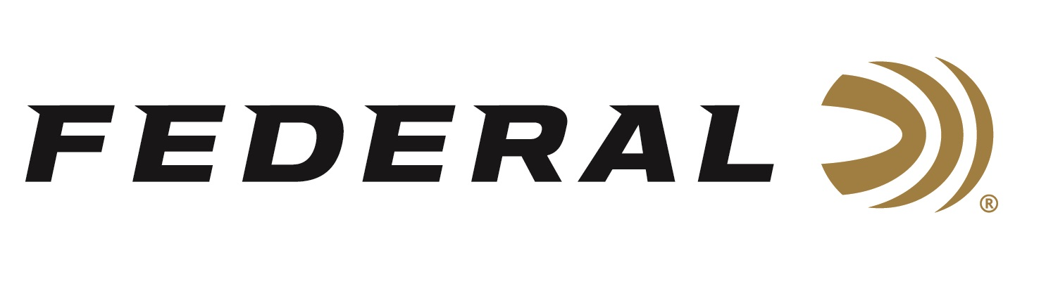

FOR IMMEDIATE RELEASE

**Federal Ammunition Adds New Prairie Storm Upland Loads Benefiting Pheasants Forever**

**ANOKA, Minnesota – October 29, 2024 –** Federal Premium adds several new loads to its popular Prairie Storm product lineup, which are part of its Pheasants Forever royalty program. Now shipping to dealers, the four new additions include 12-gauge, 2 3/4-inch magnum—which feature a softer-shooting 1,330 fps muzzle velocity—lead loads in shot sizes 4, 5, or 6, and 28-gauge, 3-inch, 1-ounce No. 6.

Federal Premium Prairie Storm shotshells are popular with upland hunters targeting pheasants and other upland birds across the prairies. These trusted upland loads utilize the rear-opening FLITECONTROL FLEX wad, a mixed payload of standard lead or steel pellets, and FLITESTOPPER lead or steel pellets to produce full, consistent patterns through any choke. Its unique wad-shot system improves the lethality of steel.

Pheasants Forever continues to lead the forces for conservation with their strong government relations team and strong presence on the ground through biologists, field staff, and outreach specialists. Their passionate staff and volunteers span the country, ensuring that wildlife and their habitats are in good hands.

“Federal is proud to grow its sponsorship of The Habitat Organization this year and beyond. The conservation efforts that Pheasants Forever and Quail Forever have put on the ground is second to none and their strategy continues to drive the organization forward,” said Jon Zinnel, Federal’s Director of Conservation. “Federal Ammunition looks forward to continuing its on-box royalty program that donates a portion of proceeds from the popular Prairie Storm and Upland High Velocity shotshell ammunition lines to these two organizations, which directly helps habitat conservation projects nationwide.

Learn more at: [Prairie Storm | Federal Premium](https://www.federalpremium.com/shotshell/prairie-storm/).

Federal ammunition is available at dealers nationwide. For more information on Federal products or to shop online, visit [www.federalpremium.com](http://www.federalpremium.com).

**Press Release Contact: JJ Reich**

Senior Manager – Press Relations

E-mail: [Ammunition@tkghunt.com](mailto:Ammunition@tkghunt.com)

**About Federal Ammunition**

Federal, headquartered in Anoka, MN, is an ammunition brand of The Kinetic Group. From humble beginnings nestled among the lakes and woods of Minnesota, Federal Ammunition has evolved into one of the world's largest producers of sporting ammunition. Beginning in 1922, founding President Charles L. Horn paved the way for our success. Today, Federal carries on Horn's vision for quality products and services with the next generation of outdoorsmen and women. We maintain our position as experts in the science of ammunition production. Every day, we manufacture products to enhance our customers' shooting experience while partnering with the conservation organizations that protect and support our outdoor heritage. We offer thousands of options in our Federal Premium and Federal® lines, which makes us the most complete ammunition company in the business and provides our customers with a choice no matter their pursuit.