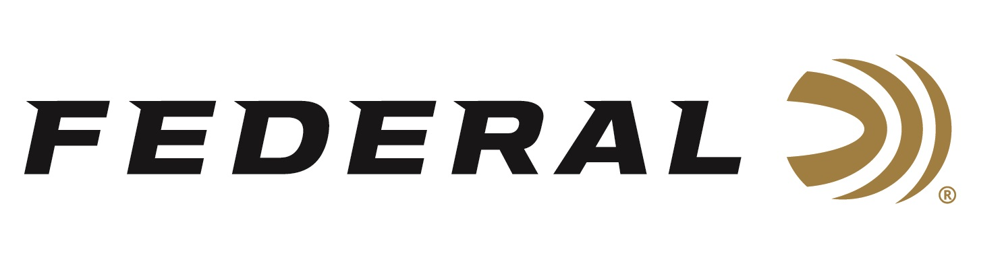

FOR IMMEDIATE RELEASE

Federal Ammunition is the Presenting Sponsor for the 2024
Pheasant Fest & Quail Classic

ANOKA, Minnesota – February 23, 2024 – The 2024 National Pheasant Fest and Quail Classic, presented by Federal Ammunition, will be held in Sioux Falls, South Dakota, March 1 - March 3. The event will bring together tens of thousands of upland hunting enthusiasts to see all the best new products including Federal Premium’s lineup of Pheasants Forever and Quail Forever branded product lines.

“Federal is proud to, once again, be the title sponsor of this big, annual event. It is great to see the outcomes of such strong conservation efforts that Pheasants Forever and Quail Forever have put forth across the country. And, this event celebrates those efforts,” said Jon Zinnel, Federal’s Senior Manager of Conservation. “Federal Ammunition also has an on-box royalty program that donates a portion of proceeds from the popular Prairie Storm and Upland High Velocity shotshell ammunition lines directly to these two organizations which helps fund habitat conservation projects nationwide. We are happy to continue that program in 2024 and in the years ahead.”

Attendees of Pheasant Fest & Quail Classic are encouraged to stop by Federal’s booth No. 1813 to talk with Federal’s enthusiastic staff about the perfect ammunition for any upcoming upland hunting adventure.

Federal Premium Prairie Storm shotshells are popular with upland hunters targeting pheasants. These loads use the rear-opening FLITECONTROL FLEX wad and a mixed payload of standard pellets and FLITESTOPPER lead or steel to produce full, consistent patterns through any upland choke. It’s excellent retained velocity and energy mean increased lethality and fewer lost birds.

Federal Ammunition recently announced its expansion of options for Prairie Storm upland hunting ammunition in 2024. The new loads include an all-new Prairie Storm Bismuth Blend product line, plus new additions to the classic Prairie Storm FS Lead existing lineup.

Federal ammunition can be found at dealers nationwide. For more information on all products from Federal or to shop online, visit www.federalpremium.com.

Press Release Contact: JJ Reich
Senior Manager – Press Relations
E-mail: VistaPressroom@VistaOutdoor.com

About Federal Ammunition
Federal, headquartered in Anoka, MN, is an ammunition brand of The Kinetic Group. From humble beginnings nestled among the lakes and woods of Minnesota, Federal Ammunition has evolved into one of the world's largest producers of sporting ammunition. Beginning in 1922, founding president, Charles L. Horn, paved the way for our success. Today, Federal carries on Horn's vision for quality products and service with the next generation of outdoorsmen and women. We maintain our position as experts in the science of ammunition production. Every day we manufacture products to enhance our customers' shooting experience while partnering with the conservation organizations that protect and support our outdoor heritage. We offer thousands of options in our Federal Premium and Federal® lines-it's what makes us the most complete ammunition company in the business and provides our customers with a choice no matter their pursuit.

