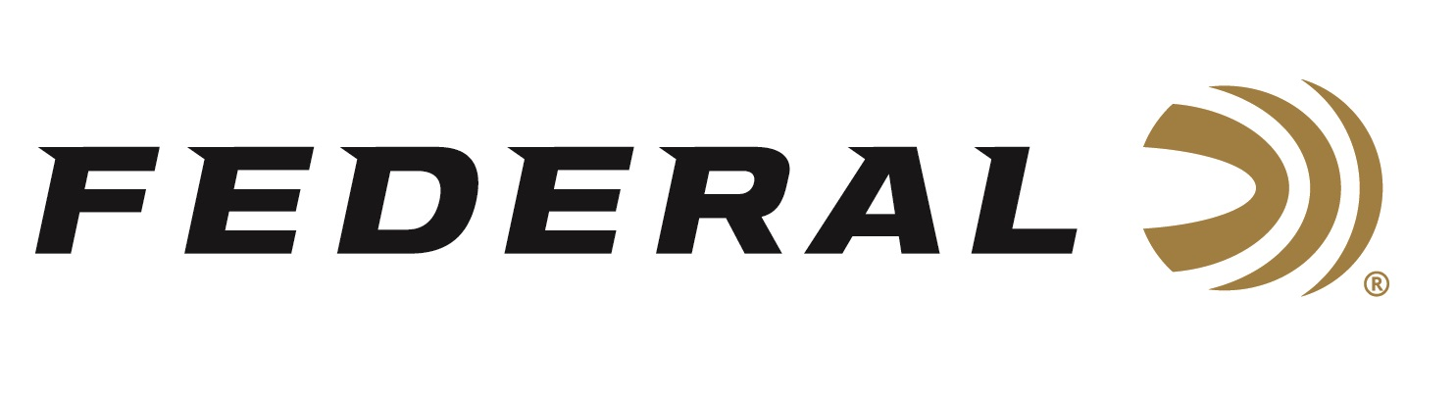
FOR IMMEDIATE RELEASE

Federal’s New Line of Premium Gun Cases, Pouches, and Bags Now Available

ANOKA, Minnesota – June 14, 2024 – Federal Ammunition recently added a Premium® lineup of accessories, including shotgun and rifle cases, shell pouches, and range bags. All are built with the finest materials, including 18-ounce waxed canvas, top-quality zippers, leather accents, brass hardware, and embossed leather logo patches. This new product line of accessories is now available at select dealers and online.

“The world leader in ammunition is now your go-to source for accessories, too. We are excited and proud to bring a new lineup of All-New Premium gear to the marketplace,” said Dan Deeb, Federal’s Director of Shooting Accessories. “Any sportsman or woman can shoot in style with this new, great-looking gear. It showcases the outdoor lifestyle and hunting heritage we all must celebrate and take pride in.”

Features and benefits of Federal’s new line of Premium gear include: 18-ounce waxed canvas; durable leather-reinforced accents; leather-wrapped, heavy-duty cotton web handles; and brass hardware. Firearms cases feature quilted padding, durable easy-slide lining, a double zipper pull opening with leather tabs, an exterior accessory pocket, and an adjustable and removable carry sling.

The product line includes six pieces: a Shell Pouch, a Range Bag, a 48-inch Shotgun Case, a 52-inch Shotgun Case, a 44-inch Spotting Rifle Case, and a 48-inch Spotting Rifle Case. All are decorated in an attractive, traditional tan color and have an MSRP ranging from $54.99 to $159.99, depending on the item.

To learn more and to see a video where Federal ambassador and professional shooter Josh Froelich walks through every item in the all-new lineups of Federal gun cases and bags, visit Gun Cases & Bags.

Federal ammunition can be found at dealers nationwide. For more information on all products from Federal or to shop online, visit www.federalpremium.com.

Press Release Contact: JJ Reich
Senior Manager – Press Relations
E-mail: Ammunition@tkghunt.com
About Federal Ammunition
Federal, headquartered in Anoka, MN, is an ammunition brand of The Kinetic Group. From humble beginnings nestled among the lakes and woods of Minnesota, Federal Ammunition has evolved into one of the world's largest producers of sporting ammunition. Beginning in 1922, founding President Charles L. Horn paved the way for our success. Today, Federal carries on Horn's vision for quality products and services with the next generation of outdoorsmen and women. We maintain our position as experts in the science of ammunition production. Every day, we manufacture products to enhance our customers' shooting experience while partnering with the conservation organizations that protect and support our outdoor heritage. We offer thousands of options in our Federal Premium and Federal® lines, which makes us the most complete ammunition company in the business and provides our customers with a choice no matter their pursuit.

