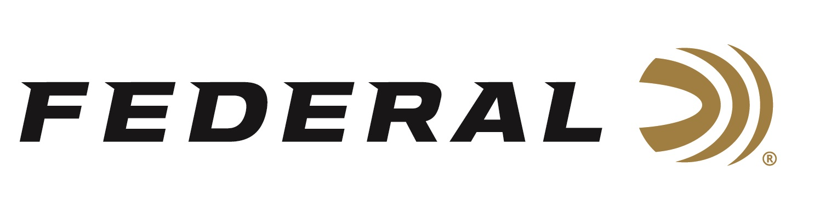

FOR IMMEDIATE RELEASE

**Federal Ammunition Announces Black Pack Bucks Rebate Program for Black Friday**

**ANOKA, Minnesota – November 19, 2024 –** Federal Premium announces its Black Friday Black Pack Bucks Rebate Program. This is a special one-month promotion on 22 LR rimfire bulk packs. Customers can now buy a minimum of two qualifying boxes of Federal 1,100-round Black Pack rimfire ammunition and get $20 back.

“Back by popular demand, customers can stock up on 22 LR rimfire bulk packs at various retail outlets. This quality ammunition certainly makes for great holiday gifts,” said Federal's Senior Manager of Trade Marketing Bart Biedinger. “Our customers can get even more value from Federal Ammunition by taking advantage of rebates and promotions.”

Rebate details include: Buy a minimum of two (2) qualifying boxes of Federal® 1,100-round Black Pack® rimfire ammunition and get $20 back ($10 per box). Qualifying Federal Black Pack ammunition is limited to manufacturer part number 36BF1100, 36-grain lead hollow point, 1,100-round box. Federal Black Pack case packs are 4 boxes, 4,400 rounds with a rebate of $10 per box or $40 per case. A minimum purchase of two (2) 1,100 round boxes is required with a maximum rebate of $100 (10 boxes) per person or household being allowed under the program.

The rebate is valid for purchases made from November 17, 2024, through December 26, 2024. The deadline for online submission is January 10, 2025. Submitting online is fast and easy, on a computer or on the go from a tablet or mobile device. The offer is valid in the U.S. and Canada.

For complete details on rebate, visit: <https://www.federalpremium.com/this-is-federal/rebates-and-promotions.html>.

Federal ammunition is available at dealers nationwide. For more information on Federal products or to shop online, visit [www.federalpremium.com](http://www.federalpremium.com).

**Press Release Contact: JJ Reich**

Senior Manager – Press Relations

E-mail: [media@tkghunt.com](mailto:media@tkghunt.com)

**About Federal Ammunition**

Federal, headquartered in Anoka, MN, is an ammunition brand of The Kinetic Group. From humble beginnings nestled among the lakes and woods of Minnesota, Federal Ammunition has evolved into one of the world's largest producers of sporting ammunition. Beginning in 1922, founding President Charles L. Horn paved the way for our success. Today, Federal carries on Horn's vision for quality products and services with the next generation of outdoorsmen and women. We maintain our position as experts in the science of ammunition production. Every day, we manufacture products to enhance our customers' shooting experience while partnering with the conservation organizations that protect and support our outdoor heritage. We offer thousands of options in our Federal Premium and Federal® lines, which makes us the most complete ammunition company in the business and provides our customers with a choice no matter their pursuit.